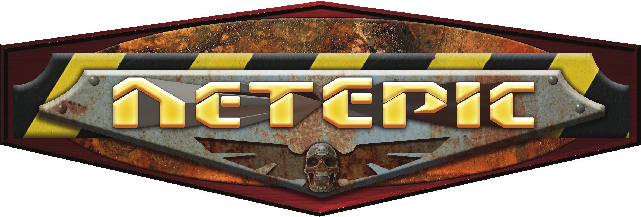

  - NetEpic Army Book

  - By the NetEpic Discussion Group

Version 3.2 (November 2018)

This rulebook is completely unofficial and in no way endorsed by Games Workshop Limited. Warhammer 40,000, Adeptus Titanicus, Space Marine, Epic 40,000, Epic: Armageddon and other names, races, characters, illustrations and images from the Warhammer 40,000 universe are either ®, TM and/or © Copyright Games Workshop Ltd 2000-2018, used without permission and their use should not be construed as a challenge to said ownership. NetEpic is a non-profit work intended for personal use and cannot be distributed with intent of profit. Concepts and ideas not owned by Games Workshop are the property of the NetEpic Discussion Group.

Table of Contents

Table of Contents 2
Background 3
The Necron Army 4
Building a Necron Army 4
Special Rules 5
Necrons 5
Reanimation Protocols 5
Barrage Weapons 5
Living Metal 5
Reserves 6
Portal 6
Phase Out 7
Necrons and Tyranids 7
Sample Army: Death Metal 8
Unit Descriptions 9
Infantry 9
Crypteks 9
Canoptek Wraiths 9
Deathmarks 10
Flayed Ones 10
Lychguard 11
Immortals 11
Necron Lords 11
Warriors 11
Pariahs 12
Triarch Praetorians 12
Cavalry 12
Canoptek Spyders 12
Destroyers 13
Destroyer Lords 13
Heavy Destroyers 13
Tomb Blades 13
Canoptek Acanthrites 13
Walkers 14
Triarch Stalkers 14
Vehicles 14
Annihilation Barges 14
Command Barges 14
Doomsday Arks 15
Ghost Arks 15
Obelisks 15
Tesseract Ark 16
Sentry Pylon 16
Knights 16
C'tan Shards 16
Seraptek Heavy Constructs 18
Tomb Golems 18
Flyers 18
Doom Scythes 18
Night Scythes 18
Night Shroud Bombers 19
Super-Heavies 19
Monoliths 19
Pylons 20
Canoptek Stalkers 20
Canoptek Sentinels 21
Tesseract Obelisk 21
Tesseract Vault 21
Others 21
Scarab Swarms 21
Summoning Cores 22
Titans & Praetorians 22
Tomb Warden 23
Warbarque 23
Abattoir 24
Æonic Orb 25
Tomb Warden Titan Template 27
Warbarque Praetorian Template 28
Abattoir Praetorian Template 29
Æonic Orb Praetorian Template 30
Necron Army Cards 31
Summary of Unit Statistics 33
Editor’s Note 35
Change History 35

Background

Necrons are artificial beings, remnants of living creatures lured by a promise of eternal life. Awakening from eons of sleep, they wish to restore their former domains.

Sixty million years ago, the necrontyr of old were among the first sentient beings to reach for the stars. Despite their short life, their aggressive interstellar colonization laid the foundations of the first galactic empire, which soon threatened to crumble due to dissent and feuds among noble houses. An encounter with the Old Ones, a mysterious and powerful race of immortals, gave the opportunity to unite the necrontyr factions against a common enemy.

Unfortunately, the Old Ones were more than a match for the necrontyr. But by an odd twist of fate, the necrontyr discovered stellar beings of immense power. They called them the C’tan. The C’tan claimed they were also at war against the Old Ones and hinted that an alliance would bring the necrontyr both victory and immortality: a deal the necrontyr cautiously accepted.

No one was able to figure out the cost hidden behind the promise. So started biotransferance: the implantation of necrontyr consciousness into artificial bodies: mechanical constructs known as necrons. Feeding on the souls of the whole necrontyr race, the C’tan were saturated with life essence. For all but nobles and high servants, minds and senses were dulled, and obedience protocols added in the process. However, the few necrons to remain sentient fully understood how they had been tricked in losing their souls and grew an unquenchable hate for the C’tan.

Hungry for more and allied with their necron creations, the C’tan utterly destroyed the Old Ones.

At this moment, the necrons chose to turn against their former allies. The new war was as short as brutal; weakened by their battles against the Old Ones and fighting necrons at their peak, C’tan were vanquished, and fragments of their essence captured. With no suitable recipient for the Apotheosis – the return of the necrons into new, living bodies – they entered stasis, planning to wait for the appropriate moment under the watchful guard of Triarch Praetorians.

Millennia later, sentient life teems again… and the necrons’ moment has come. After eons of silence, Tomb Worlds awake throughout the galaxy. Few necron lords have fully understood the changes that have happened, but even if necron race is not united yet, all want to restore (or expand) on their ancient holdings. Following their own undecipherable goals and having access to Portal technology, no one can guess which world they will attack next.

The Necron Army

The Necron Army List is a Codex army. You must take at least 75% of your points from this book.

Necrons will, should the need arise, form temporary alliances with humans and eldar, in order to deal with a common enemy. Where resources are short, they will also use Mindshackle Nanoscarabs to take control of the leaders of lesser races such as Orks, to use as cannon fodder until their slumbering legions can be awoken. However, no necron, however desperate, insane or depraved, will consider doing so with Tyranids, so you cannot use a Tyranid allied force.

Note: This document is not an official NetEpic army book and should be considered optional. You must have the permission of your opponent(s) before crushing them with it...

Building a Necron Army

A Necron army is built following the same rules as other forces. You may purchase Company, Support and Special cards up to the nominated point limit of the battle. For each Company card selected you may take up to 5 Support and 1 Special Card worth of units.

Optional Rule: Tomb World
Sometimes a battle with Necrons takes place on a Tomb World, a desert world where necrons have slept in stasis for millennia. So close to their underground bases, necrons fight with a renewed energy.

On a Tomb World, ignore Phase Out rules. Plus, per 2,000 points of the Necron Army, you can either install one Portal (Knight) or two Portals (Vehicle) on terrain features, for free. Those Portals can’t be destroyed unless the terrain feature itself is removed through a special effect. Yet, a battle on a Tomb World usually means necrons are reacting to intruder invasion. They don’t have time to activate their largest units. As a result, a necron army fighting on a Tomb World can include no unit of Titan / Praetorian size.

A necron vs. necron battle does not prevent Tomb World rules from being used, even by both players. In that case, to each his or her own set of Portals.

Special Rules

Necrons

All units from this list have both the Artificial Intelligence and Inorganic Special Rules, as described in the NetEpic Core rules.

Reanimation Protocols

Possibly the most terrifying necron characteristic is their ability to regenerate from nearly any damage and return to fight once more: a faculty granted by the Necrodermis alloy they are created from, combined with an uncanny ability to repair damage. Most necron units show an unnatural resistance and even necron infantry benefits from some armour save, a fixed saving throw, or a combination of both.

Barrage Weapons

Necrons perfected their military might over ages and feature many of the most powerful weapons of the 41st millennium, using accelerated beams of particles, etheric bolts or even anti-matter. Many of these saturate an area with dreadful energies and are likely to destroy everything there: an effect translated in-game through a barrage value. However, necrons use no shells or missiles allowing a parabolic path. For this reason, unless specified otherwise, necron weapons firing Barrage Points are not truly artillery and may not fire indirect barrages.

Most of the time, necron models fire barrages independently from each other. In unit statistics, weapon profiles are written as “4 BP, 5+”, showing to to-hit roll for models underneath the template. Each model in the firing unit chooses its target freely; barrage templates need not touch one another either.

When barrages of different models in the unit do combine, however, the to-hit number is not listed as it is related to the number of models firing. In unit statistics Barrage Points are written as “3 BP@” for example (meaning “3 Barrage Points each”). Models combine their firepower in a single barrage template.

Each weapon has its own behaviour; it’s even possible to have separate and combined barrage weapons in a single unit.

Living Metal

Necron Titans, Praetorians and other large units are protected by a layer of Necrodermis armour appearing as a reaction to impact. Combined with the countless scarabs repairing structure at molecular level, necron armour is almost indestructible. This is translated into game terms by a Living Metal score.

Living Metal offers a global protection against ranged weapons. When the enemy player scores a hit against a model with at least one Living Metal point, roll a die (after rolling to scatter if the target has a hit location template): if the result is greater than the TSM of the attack, the hit is negated. If the roll is equal to or lower than the TSM of the attack, the hit is still negated, but one point of Living Metal is lost.

For example, a Tomb Warden with 1 point of Living Metal left is hit on the Hull by a lascannon with a -2 TSM. A die roll gives a 5: the laser beam is harmlessly absorbed by the armour. Later in the turn, a Leg is hit by a siege mortar with -3 TSM: another die roll gives a 3. The hit is negated but the last point of Living Metal is gone, leaving the war engine vulnerable to further attacks.

Obviously, a weapon with no TSM cannot damage a Necron Praetorian unless its Living Metal protection has been depleted first. Living Metal points may be restored in the End Phase through a Repair roll.

Living Metal has no effect on close combat.

Reserves

Necrons strike suddenly and disappear without a trace. Their mastery of teleportation gives them opportunities for tactical redeployment and an optimal allocation of their forces.

During army setup, any number of non-flyer units may be kept in Reserves as long as they have a mean of reaching the battlefield, like Portals (see below) large enough for them or special rules like Deep Strike or Teleport, etc. “Reserves” refer to a place far from the actual battlefield, perhaps in the depths of a Tomb World light-years away - the exact location is not important. Units in Reserves receive orders normally. They are unable to attack or to be attacked in any way while in Reserves. Each unit is activated as usual and may reach the battlefield through a Portal or other means during its activation.

A unit in Reserves with no means of reaching the battlefield counts as destroyed.

Portal

Necrons use Portals to cross long distances. Portals are typically installed on Monoliths, but other passages do exist. Crossing a Portal allows a unit to move into or out of Reserves. Crossing a Portal costs 5cm of movement for the crossing unit and nothing for the unit carrying the Portal. A Portal may be used regardless of the movement of the unit carrying it. There is no limit to the number of units crossing a single Portal in a given turn, and a single unit may also cross several Portals during its activation. Destroying a Portal has no effect on units that crossed it earlier. Portals come in different sizes and each unit description mention the largest pinning class allowed. For example, a Portal (Vehicle) means that any unit of Vehicle size or smaller may use this Portal.

Models exiting from a Portal appear within 1 cm of the unit carrying the Portal, usually in its front arc, and can continue their movement from that point if they have any left.

A unit crossing a Portal should do so entirely. If for any reason the unit can’t cross the Portal completely at the end of its activation in the Movement Phase, models left behind (on the battlefield or in Reserves, accordingly to the way Portal was crossed) activate Phase Out teleporters and are removed from play. They count as destroyed for all game purposes.

Only friendly Necron units may cross a Portal.

Phase Out

Necron commanders follow their own schemes and sometimes vanish without warning: perhaps a Phaeron finally experienced the long-forgotten feeling of fear once again, or some offense to the Necrons’ undecipherable Code of Honour has been cleansed, unless the whole battle was only an excuse to weaken an untrusted subordinate. For this reason, most Support Cards add to the Break Point and Victory Points of the Company they are attached to. The result needs to be computed beforehand. For all other intents and purposes, Support Cards form their own detachments and are separate from other units in the army, as usual.

Once the break point of the combined Company is reached, the whole group withdraws to a safe place through teleportation. All remaining forces of the broken group are removed from play in the end of current phase and regardless of pinning rules. Necron opponent is awarded Victory Points for the combined Company and Support Cards.

When a Company phases out, other companies and their respective Support Cards are unaffected (but watch out for a chain reaction due to loss of Portals!) Units available as Special Cards are unaffected by Phase Out rule, no matter what becomes the Company that allowed to field them.

Necrons and Tyranids

Tyranids are ill-suited to fight necrons since the latter can retreat at will, leaving the Hive Mind raging in anger. However, Tyranids are prompt to hold land and are granted extra Victory Points when necron units leave play due to Phase Out rule.

Against Tyranids, disregard the victory points listed for necron companies and Support Cards. Instead, when a Company phases out, the Tyranid player is awarded a number of VP equal to the cost of the combined Company and Support Cards, divided by 50. For example, a necron Company and Support Card worth 1700 points grants 34 VP to a Tyranid opponent when phasing out (1700 / 50). For units purchased as Special Cards, Tyranids receive the double of the VP listed.

Tyranid player also wins if there is no Necron unit left on the battlefield in any End Phase (flyers and tunnelers don’t count.)

Sample Army: Death Metal

Army Card Cost Notes
1) Venator Legion 1000 Break Point 14, VP 13
Warrior Phalanx 250 Break Point +6, VP +4
Tomb Golem Triceps 250 Break Point +2, VP +3
Destroyer Eques 250 Break Point +5, VP +4
2) Obelisk Praecursor 800 Break Point 9, VP 11
Tomb Warden Titan 450 Break Point 1, VP 5
Total 3000

This sample army contains two Companies. The first one is composed of the Company itself and three Support Cards for a combined break point of 27 before phasing out (see Necron special rules above) and 24 VP. The second Company has no Support Card, its break point is not modified and stands at 9 for 11 VP. Finally, The Tomb Warden is a lone Titan whose break point is the model itself. It is worth 5 VP.

Unit Descriptions

Special abilities applying to each unit are listed under its description. Abilities not detailed in each unit are described in NetEpic core rules.

Infantry

Crypteks
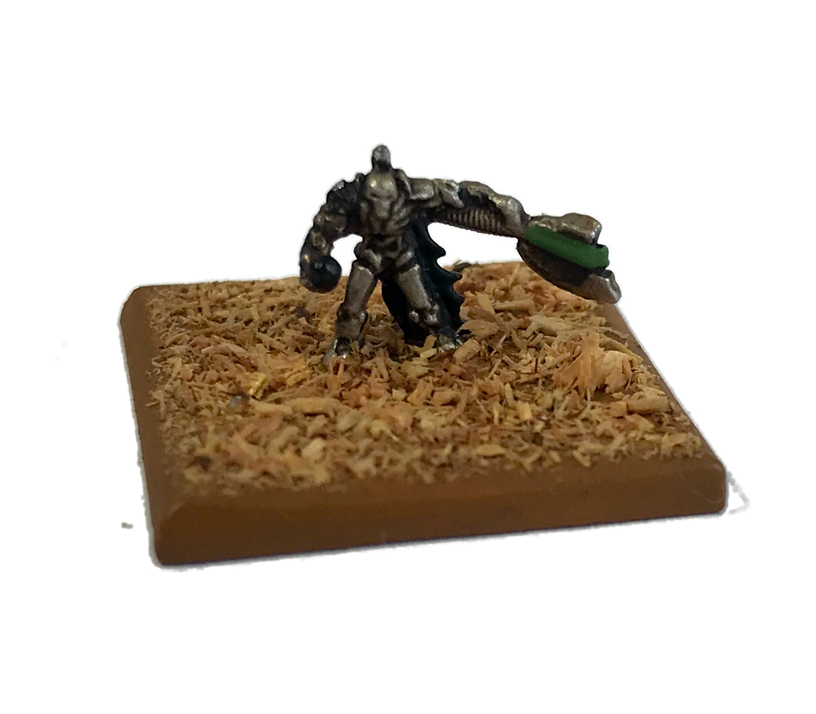
Crypteks do not belong to the ranks of the Nobility but retain a critical role in necron affairs, as they maintain the eldritch devices of Tomb Worlds. Each Cryptek is affiliated to a Conclave specialized in one aspect of their arcane science, but all can unleash incredible forces lesser races would call “magic”: slowing time, driving minds to madness, or simply reducing armour to molten ashes. Unfortunately, Conclaves compete for prestige and distrust each other. This oddly led to Crypteks fighting together in campaigns: this way, not only each Cryptek can keep an eye on challengers but may also demonstrate the superiority of his own discipline in the midst of battle.

- Command.
- Defence field: using Chronometrons and fear-inducting devices, Crypteks can hinder enemy troops. In the beginning of the Close Combat segment, place a barrage template centred on the Cryptek stands: any enemy model touched by the template and fighting in close-combat this turn rolls one less D6 to its CAF. The maximum penalty is 1D6, regardless of the number of Defence fields a model is under influence of.
- HQ.
- Tools for the job: Crypteks use a variety of ranged weapons, but for some reasons can only use one of them every turn. The same weapon may be used on consecutive turns.

Canoptek Wraiths
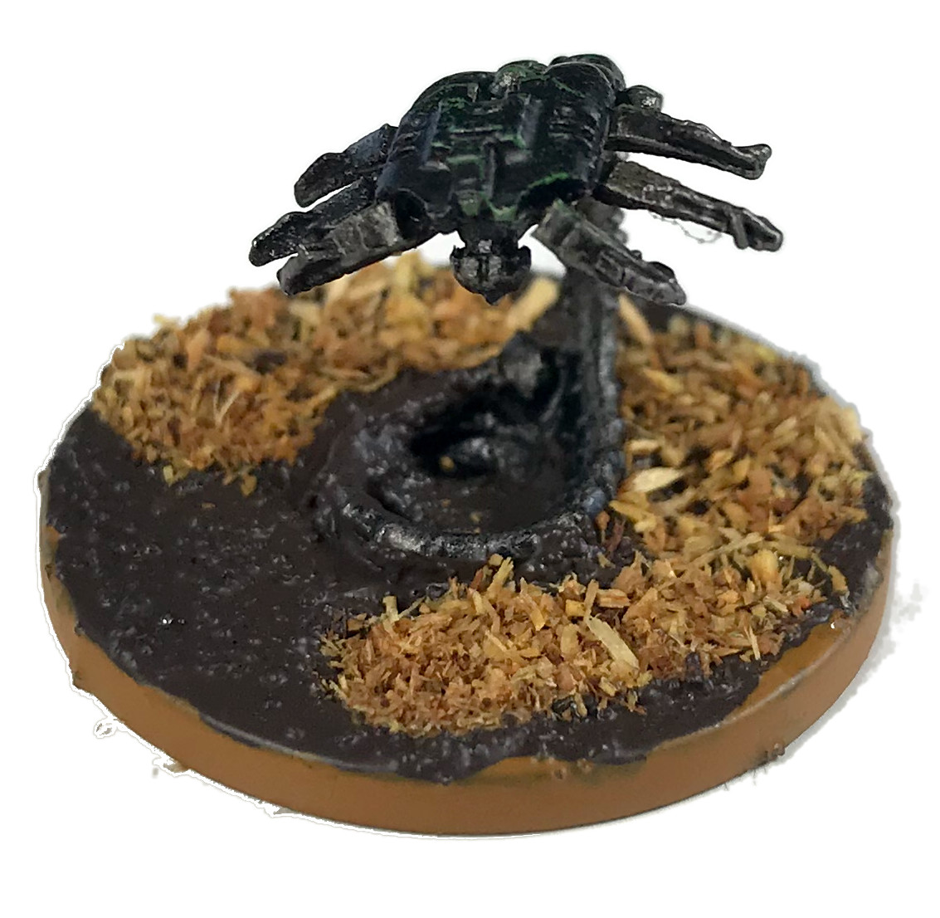
Canoptek Wraiths hover over the battlefield. Wraiths did not awake like other necrons, for these ghostly creatures numbered among those in charge of Tomb World maintenance. They can wholly or partially phase in and out of reality, an ability working wonders to repair complex mechanisms without having to dismantle the frame – and a deadly advantage on a battlefield, their weapons bypassing most armour.

- Hard to Hit.
- Jump Packs.

Deathmarks

Deathmarks track their target long before the battle. Hunters and assassins before becoming necrons, mechanical bodies perfected them, removing any need to sleep or breathe and granting them dead cold accuracy and eternal vigilance. Deathmarks teleport onto the battlefield from the dimensional pocket they were hiding in and finally cripple their target. As goes the saying, once tracked by Deathmarks, there is no escape.

- Deathmark: if a Deathmark unit enters battle through teleportation, place a single “Deathmark” marker on one enemy model with Headquarters, Command or Combat Leader ability in LoS and within shooting range of one stand, no larger than Knight size (if no target is eligible, the marker is lost). Any Deathmark stand has +2 to hit a model bearing such a marker, automatically succeeds HQ identification, and receives a +2 on CAF when fighting the model in close-combat. The marker lasts for the entire battle or until the victim is destroyed. If the marked model locks itself in a transport, the transporting model also gets a Deathmark marker as long as it carries the marked model. A model may bear only one Deathmark marker.
- Sniper.
- Teleport.

Flayed Ones

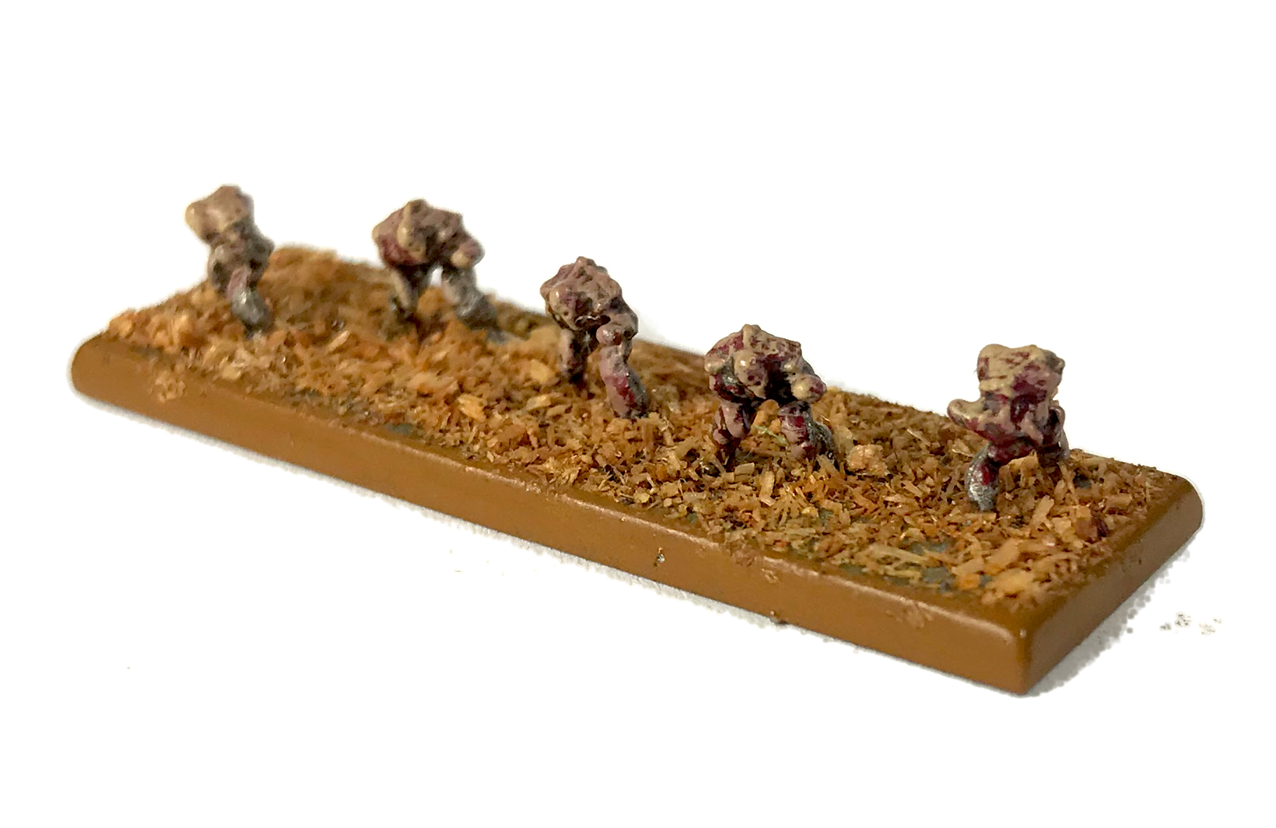
Flayed Ones were necrons long ago but fell victims of the curse of one of the last C’tan, Llandu'gor the flayer. The curse spreads slowly but reveals itself only after millennia, so most Tomb Worlds are now affected. Flayed Ones suffer from an unquenchable thirst for flesh and blood. They sometimes adorn themselves with still-wet pieces of skin and hide from their latest victims, a terrifying sight to behold. Incarnation of the madness awaiting every Phaeron, necron nobles hate them - but still recognize their utility in disrupting enemy lines. Able to sense opportunities for blood better than any commander, Flayed Ones are often the first troops on the battlefield and retreat back to their secret lair only once their macabre feast is over.

- Fear.
- Infiltration.
- Outcasts: Flayed Ones start battle deployed on the battlefield and can’t enter Reserves nor cross a Portal. Flayed Ones units follow the usual Phase Out rule, but Flayed Ones Support Cards contribute neither to the victory point nor the break point of their parent Company. If Flayed Ones Support Card can be taken for any necron Company, a Flayed One Company card can receive only Flayed Ones units for Support Cards.

Lychguard

Lychguard have always been wardens of the nobility, incorruptible and dedicated to their task to the death, but only became true to their legend after biotransferance in necron bodies. Lychguards have the same superior envelope as nobles and carry deadly close-combat weapons, either two-handed warscythes or hyperphase swords along with dispersion shields.

- Elite.

Immortals
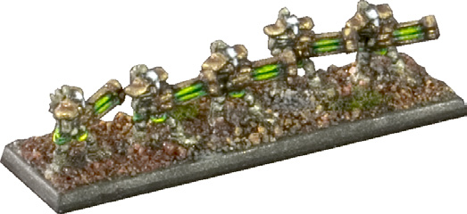
Necron Immortals earned their reputation during campaigns against the Old Ones, and their transformation gave a new meaning to the expression “hardened veteran”. They received better mechanical bodies than mere Warriors and can wield Gauss Blasters thanks to their stronger limbs, packing much more firepower than lighter versions.

Necron Lords
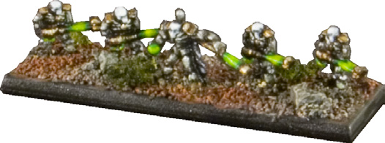
Necron Lords, ranking up to Nemesors and Phaerons, are leaders of necron forces and last heirs of the necrontyr. They fully retained sentience, ambition and anger. Apt commanders, they increase the efficiency of nearby necrons through advanced equipment like the Resurrection Orb. Necron Lords hold many titles related to their rank in the nobility, but also to the prestige of the Tomb World they originate from. Some of them embrace the cause of Destroyers and are mounted on the same platforms than them (see Destroyer Lords entry below).

- Combat Leader.
- Command.
- Elite.
- HQ.

Warriors

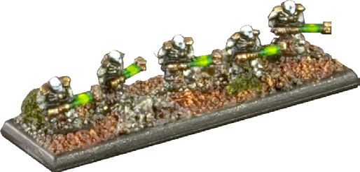
Necron Warriors constitute the backbone of most Tomb World armies. Numerous and deaf to any sense of danger, they provide strong fire support with their Gauss Flayers. Although not as elaborate as higher rank necron ones, their bodies allow them to sustain massive damage and continue functioning.

- Gauss Flayers: lightest of all Gauss Weapons, Flayers still pack some punch and may even pierce armour. Each time a 6 is rolled on a to-hit die, the hit has a TSM of -1 instead of 0. If the score to reach was 7 or higher, any successful hit benefits from this additional save modifier.

Pariahs

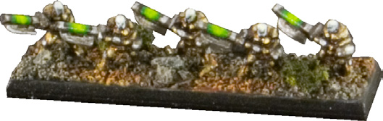
Pariahs, a rare necron experiment, were created just before the Long Sleep through application of biotransferance on non-necrontyr slaves. Thanks to obedience protocols, they fought alongside their masters, radiating an unnatural aura severely unnerving their enemies. Their numbers are dwindling over time as Pariahs are unable to self-repair like other necrons. Each Pariah wields a unique combination of warscythe and built-in energy weapon.

- Elite.
- Psychic abominations: Pariahs are able to adversely affect Psykers with their powerful emanations of dread. Any enemy Psyker within 25cm of a Pariah stand may only use psychic powers if he first rolls 5+ on a D6.
- Soulless: Any unit within 25cm of Pariahs count as having a Morale value of 4, unless it was worse.

Triarch Praetorians

Triarch Praetorians were trusted lieutenants and heralds of necrons kings with a duty to preserve necron dynasties, reason why they chose not to enter the stasis of the Long Sleep. Wardens of Tomb Worlds and witnesses of what the galaxy came across, the threat posed by Tyranids to the Apotheosis forced them into awakening and unite necrons again. Praetorians choose the appropriate moment to strike, as they involve only if the fight is worth it in their eyes. With the Rod of Covenant they carry, they can surely make a difference.

- Jump Packs.

Cavalry

Canoptek Spyders

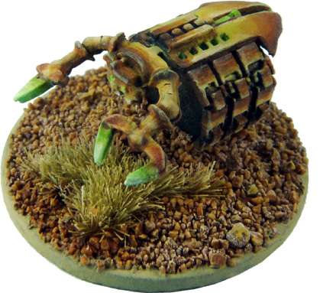
Canoptek Spyders, also known as Tomb Spiders, are large spider-like robots whose purpose is to maintain necron tomb complexes. The task would deem impossible if it was not for the help of clouds of Scarabs, small beetle-like robots that Spyders can generate almost endlessly to assist them. In battle, Scarabs find another usage to support other Necron units and engage nearby enemies.

- HQ.
- Scarab Generator: if a Canoptek Spyder is on the battlefield, instead of shooting, roll a die: if the result is equal to or lower than the number of friendly Necron infantry stands within 15cm, even in a transport, you can add a Scarab counter to the army (if 6 stands or more are in range, success is automatic). See Scarabs Swarms entry for details. This ability can’t be used if the Canoptek Spyder is on Charge orders.
- Skimmer.

Destroyers
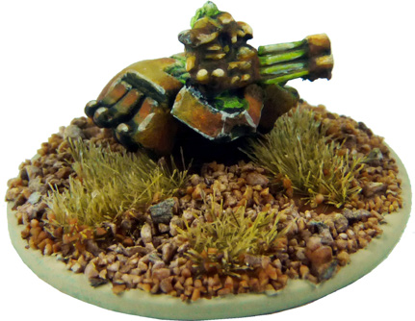
Destroyers’ sole reason for existence is to cleanse life. While other necrons longs for the days they were living beings, Destroyers embrace their mechanical form fully, fusing arms and weapons for better accuracy, trading legs for a hovercraft platform for added mobility. Their Gauss Cannons and sophisticated targeting systems lay destruction in their wake.

- Skimmer.

Destroyer Lords

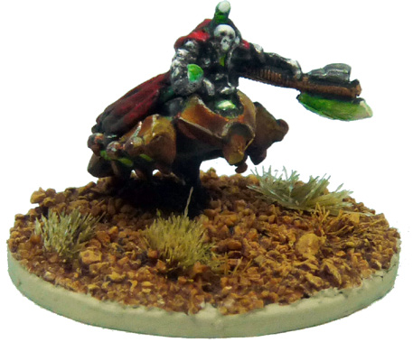
Destroyer Lords act as leader for Destroyer phalanx and draw obedience only from their burning hate for all sentient creatures. While Destroyers carry ranged weapon of some sort, Destroyer Lords shun them and carry only a warscythe, as they want to see fear in the eyes of the enemies they kill.

- Combat Leader.
- Command.
- Elite.
- HQ.
- Skimmer.

Heavy Destroyers

Heavy Destroyers, more specialized version of their nihilist brethren, will do whatever is necessary to ensure the demise of enemy armour – a goal they are likely to achieve thanks to their Heavy Gauss Cannon.

- Skimmer.

Tomb Blades

Tomb Blades number among the few units whose design predates the creation of necrons. The light skimmer is little more than a necron jetbike featuring some Tesla weaponry and an artificial intelligence to supplement the poor reflexes of its necron pilot. The result is a fast flying skirmisher able to make accelerations and razor-sharp turns no living creature could endure.

- Hard to hit.
- Skimmer.

Canoptek Acanthrites

Unlike Canoptek Spyders, who serve as both guards and caretakers of necron tomb complexes, Canoptek Acanthrites are designed solely to hunt down and destroy all mortals foolish enough to enter their masters’ domain. When necron legions reclaim a world, the Acanthrites are often at the vanguard, and can swarm through and devastate entire cities with their nightmarish weapons.

- Skimmer.

Walkers

Triarch Stalkers

Triarch Stalkers look like giant arachnids. Their multiple limbs let them cover all kinds of terrain without even slowing down like maladroit walkers and tanks employed by lesser races. Stalkers field enough firepower to wipe out enemy armors and are fast enough to retreat before infantry reacts. Should the threat get too close, the Triarch Praetorian controlling the Stalker can switch weapon mode to short-range bursts and mow down enemy troops.

- Targeting relay: if a Triarch Stalker scores a hit with its Heat Ray on an enemy model but does not destroy it, place a “Target” marker next to the model, unless it already has one. All friendly Necron units gain +1 when shooting at a model bearing a Target marker, except Triarch Stalkers. Remove all Target markers in the End phase.

Vehicles

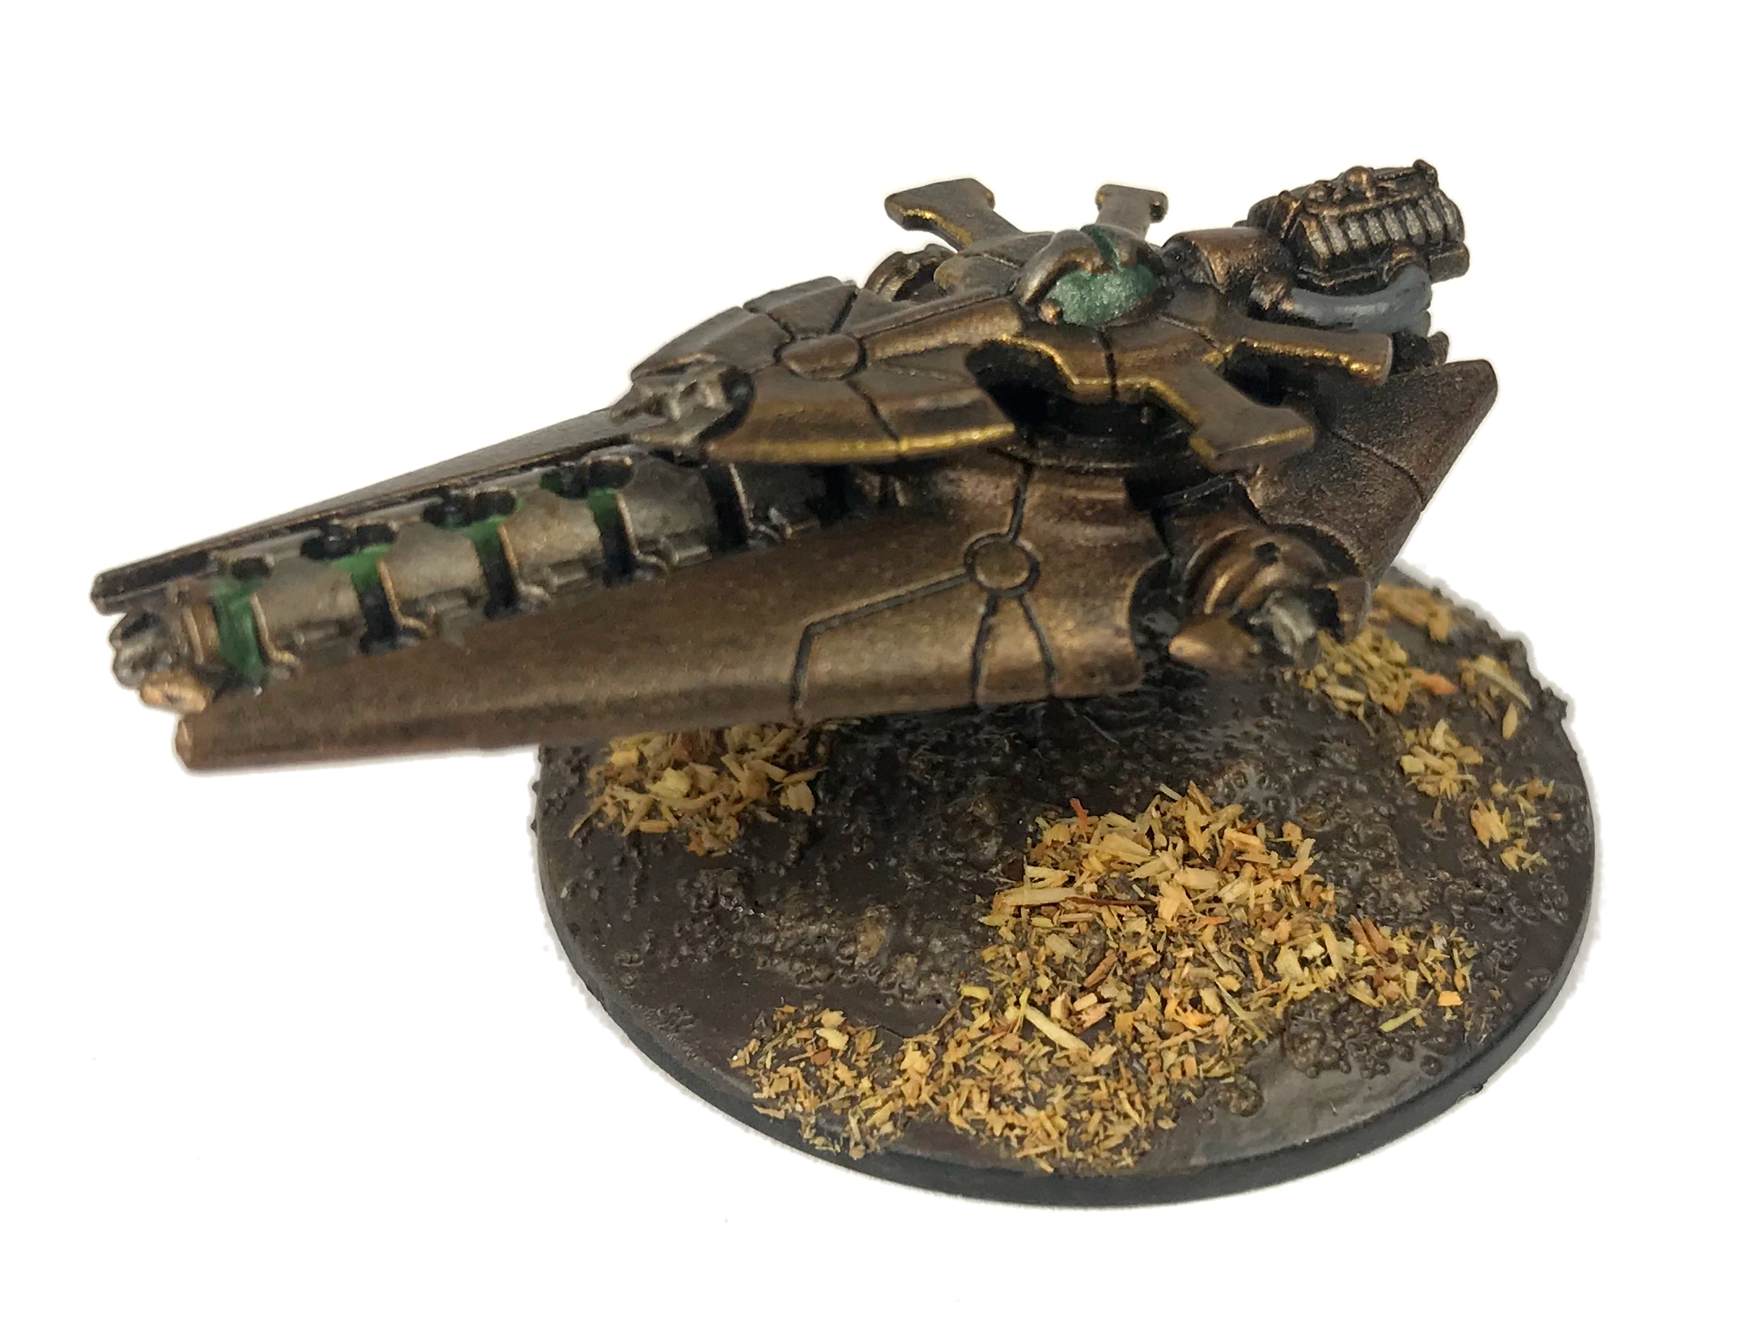
Annihilation Barges

Usually buried in the depths of Tomb Worlds, Annihilation Barges are little more than an array of flux weapons on an anti-grav platform. Their primitive but specialized AI feels a painful thirst for killing infantry. Annihilation Barges are widely used against large concentration of forces and are often the bane of Orks.

- Point Defence (2).
- Skimmer.

Command Barges

Command Barges invariably carry the necron commanders with the utmost interest at stake in the ongoing battle. Necrons do not believe in delegation of responsibilities – an assault must be led personally not only to ensure battle plans are being carried out properly, but also to impress political rivals. The Command Barge allows both, along with a clear view of the onslaught and a retractable ramp to let the commander join the fray if he feels so inclined.

- Combat Leader.
- Command.
- HQ.
- Point Defence (2).
- Skimmer.

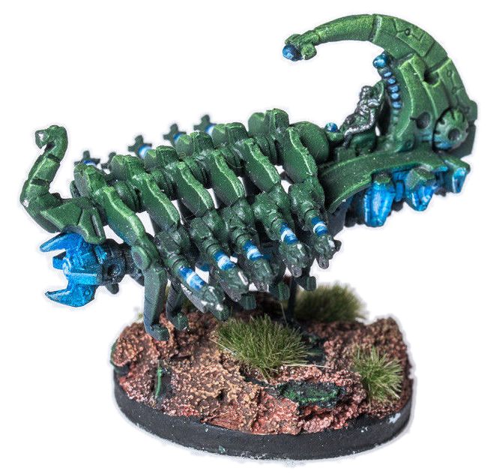
Doomsday Arks

Doomsday Arks feature token anti-infantry defences, are not especially durable and lumber at slow speed. Yet, they embody necron battle philosophy almost perfectly – destroying the enemy before it can do any harm – thanks to their Doomsday cannon, the most powerful weapon of the necron arsenal bar legendary artifacts such as the Æonic Orb.

- Doomsday Cannon: the Doomsday Cannon has two profiles, the best one is used only when the model carrying the weapon didn’t move at all during the Movement Phase; doing a pop-up attack counts as a movement for this purpose. The Doomsday Cannon has only a 90° firing arc to the front of the Ark.
- Point Defence (2).
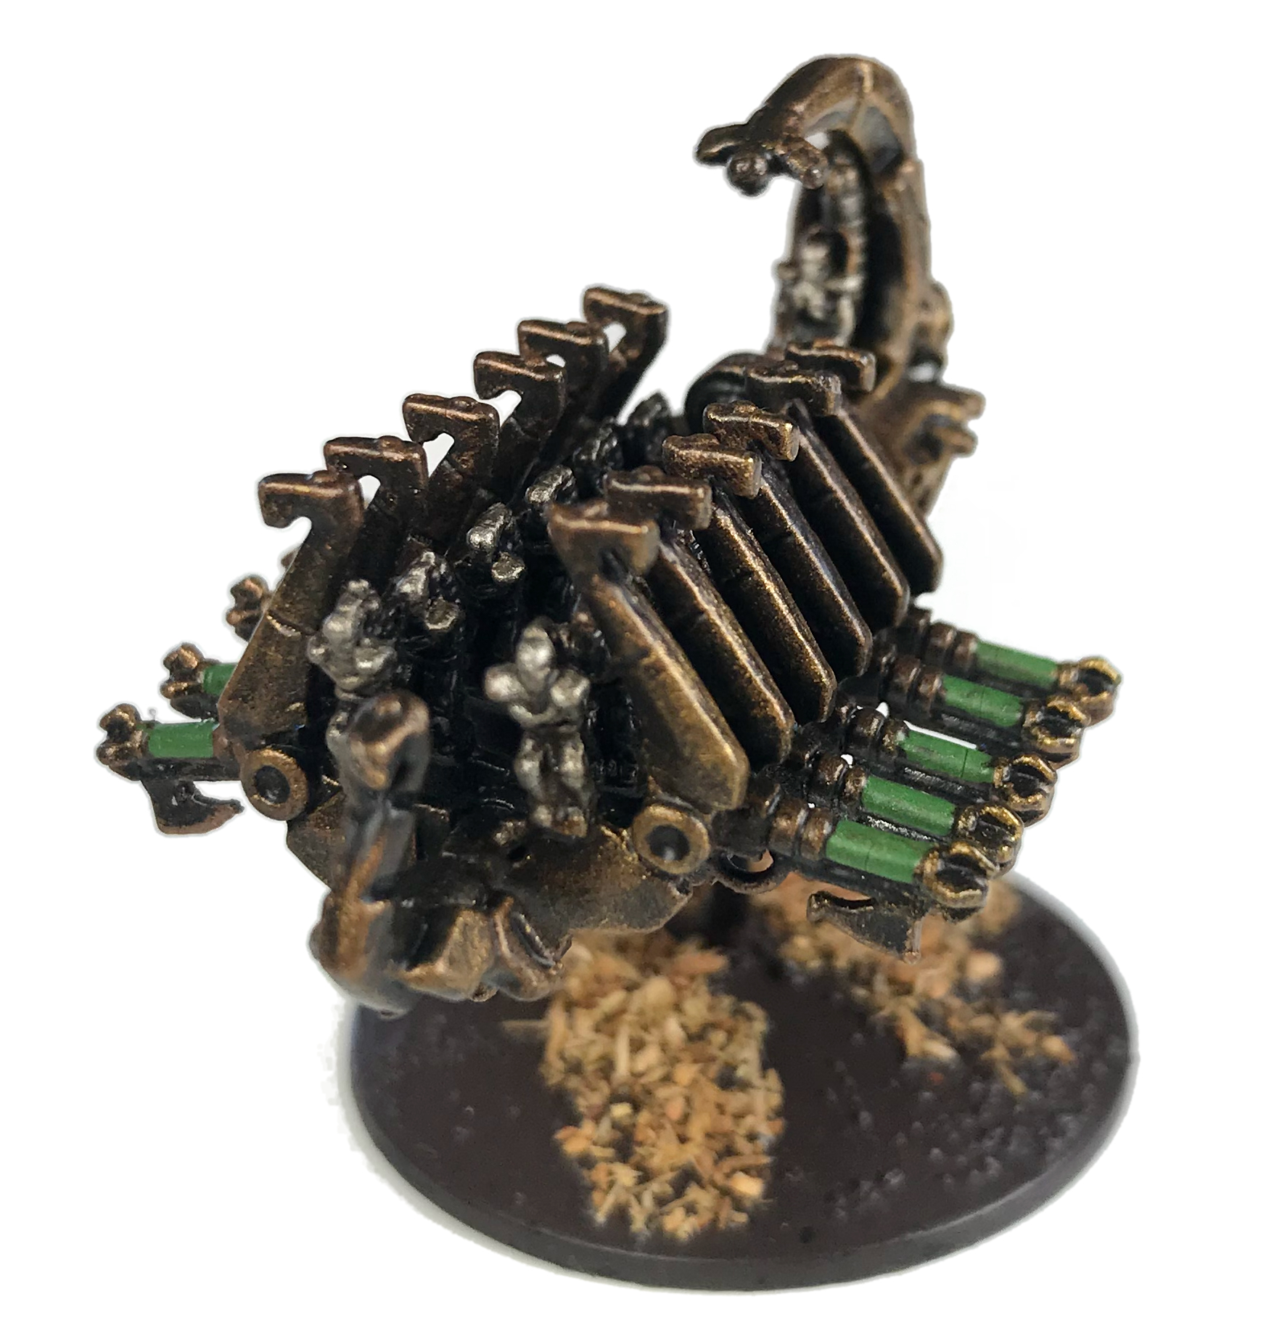
- Skimmer.

Ghost Arks

Ghost Arks do more than just transporting necron warriors where their firepower is most needed; these anti-grav vehicles act as mobile repair stations as well, further enhancing the threat posed by an almost-indestructible infantry.

- Point Defence (2).
- Repair Platform: any necron Warrior stand within 15cm of at least one Ghost Ark benefits from boosted reanimation protocols and sees its invulnerable save – not its regular save – improved by 1.
- Skimmer.
- Transport (2). Ghost Arks can embark two stands of Necron Warriors only.

Obelisks

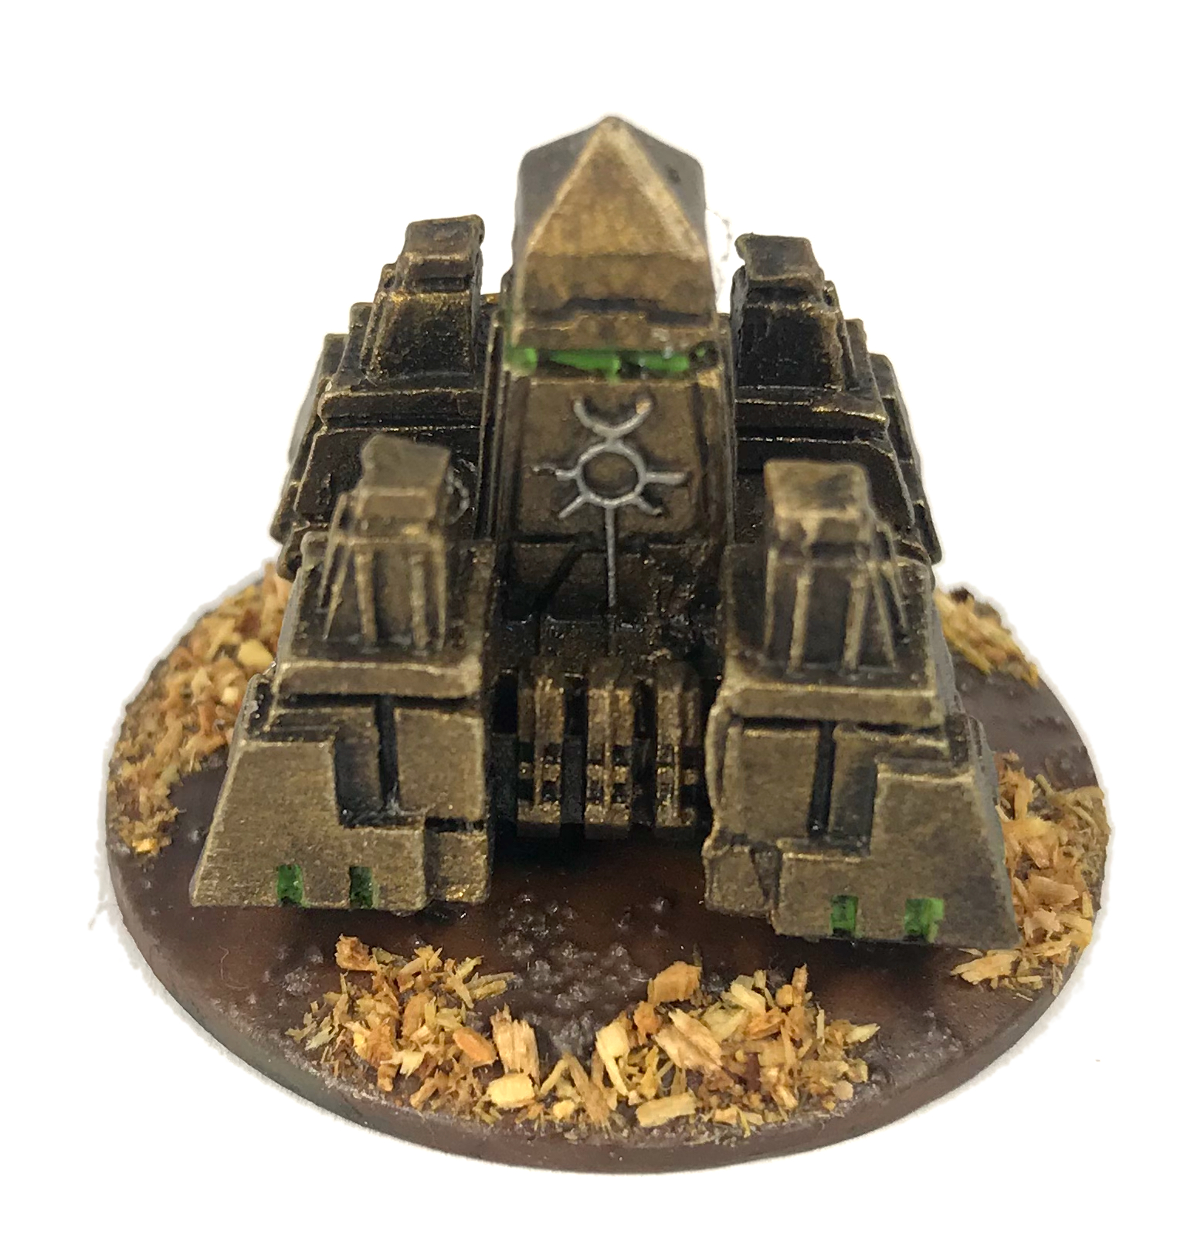
Obelisks are strange constructs over a square base sharing the same crystal matrix as Monoliths. Formations of Obelisks provide support to infantry or perform raids deep in enemy lines. Many worlds were covered by arrays of rectangular stones eroded by time, which cracked and exploded one day only to reveal the lethal shape of the Obelisk within, and an awakening Tomb World.

- All-Around Armor.
- Ignore Cover: The Flux Arc fired by Obelisk ignores to-hit modifiers for cover.
- Skimmer.
- Teleport.
- Turret: the Flux Arc has a 360° arc of fire.

Tesseract Ark

Tesseract Arks are manned by a single necron warrior but carry a devastating armament: nestled deep within the ark is a naked singularity, torn from a dying star, that can be used to unleash a devastating blast of energy which can annihilate almost any target. In order to contain this immensely powerful object, Tesseract Arks are heavily armoured, which means that they are also resilient against enemy firepower.

- Heavy Skimmer.

Sentry Pylon

Sentry Pylons resemble scaled-down versions of the more powerful super-heavy sibling and are often deployed to protect critical locations within tomb complexes.

- Skimmer.
- Slow: Sentry Pylons move only in a limited manner. They can move up to 10cm on Charge Orders only.

Knights

C'tan Shards

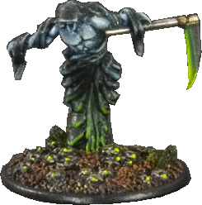
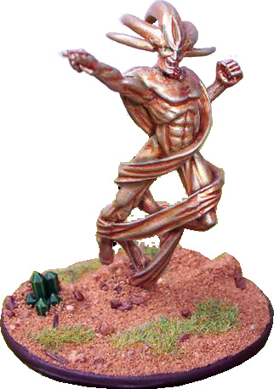
C’tan shards, or Shards, are sole remnants of the mighty creatures which created the necrons. C’tan were immensely powerful and necrons discovered too late that they could not be completely erased from existence. The pitiful remains of once-mighty C’tan still burn with a fragment of their earlier personalities, and the powers to match. Necron nobles release Shards grudgingly and only in direst circumstances; a Shard is under constant scrutiny. Should it rebel, turn its attention elsewhere or have the integrity of its Necrodermis prison compromised, it can be instantly teleported back to a stasis chamber where it will languish for several centuries.

A Shard is not destroyed after a failed save or a defeat in close combat. Each time a Shard should be destroyed by a ranged weapon, give it a damage counter instead. If the Shard is defeated in close combat it takes a number of damage counters equal to the difference in the scores. If the Shard has 6 or more damage counters at any time, its Necrodermis body explodes while the Shard is immediately removed from play. All models within 1D6 cm must make an unmodified save to avoid destruction.

All Shards feature these special rules:

- All-Around Armor.
- Elite.
- Command.
- Psychic Save (2+).
- Psyker.
- Skimmer.

In addition, each Shard possesses one Psychic Trait among five. Traits should be as diverse as possible, so a Trait can be duplicated only if at least six Shards are selected in the army, and so on. Necron opponents must be told of the abilities of each Shard prior to battle. Here is the list of Psychic Traits:

- Gaze of Death: when the Shard turns its attention towards enemies, it means death. This trait grants the special rule Terror to the model. In the First Fire segment, the Necron player may place a barrage template anywhere within LoS of the Shard. Any unit more than half covered by the template suffers 8 BP with a -6 TSM. This is not a regular barrage and does not damage buildings. The attack causes D6 wounds on multi- wound creatures. The Gaze of Death is a physical psychic attack.

- Ætheric Rage: the Shard can create a tempest of negative energy. In the First Fire segment, Place the large 12 cm template centered on the Shard. All vehicle-class models and smaller are hit on a 4+ ignoring cover with no TSM, unless they are Inorganic. For each model destroyed this way, the Shard can remove a damage counter. The Ætheric Rage is a physical psychic attack.

- Deceit: the Shard is an unequaled master in illusions, and gains the special rule Stealth. In the First Fire segment, it can temporarily take control of a single enemy unit with at least one model in LoS up to 25cm away, containing no model larger than vehicle size. Victims open fire on foul creatures appearing from nowhere, but are in fact shooting their own comrades! Resolve immediately a round of fire from the affected unit under Necron player control (even if the unit moved on Charge order or already fired in this segment). Targets can be chosen regardless of affiliation – models in the affected unit can even shoot one another – but pinning rules still apply. Snap Fire and popup attacks are not possible. The Necron player may opt not to fire with all weapons available; regardless of what happens under the illusion, the unit can’t fire anymore this turn. Deceit is an ethereal psychic attack.

- Raging Inferno: the Shard is engulfed in flames and all the area is filled with sparks. The Shard can’t be outnumbered in close-combat: no extra D6 to CAF is awarded because of multiple assailants. The Shard is also immune to any plasma or fire-based weapon. Within 30cm of the Shard, these weapons cease to function (they work again if models are more than 30cm apart later). Finally, in the First Fire segment, the Shard can invoke the power of a Raging Inferno on largest foes. Choose an enemy model featuring a hit location template within 30cm of the Shard, no LoS being required. Pick a location and roll for deviation as usual: the model suffers a critical hit on the final location, no save allowed. Alternatively, the Shard can inflict a single hit with no save on a Super heavy vehicle instead, just roll for damage on the appropriate table. Raging Inferno is an ethereal psychic attack.

- Molder of Worlds: the Shard can alter reality as it sees fit. In the First Fire segment and within 60cm and in LoS, the Shard can, once per turn, either:
  - Destroy a building. This is a physical psychic attack.
  - Create a bottomless rift, a straight line 1 cm wide and up to 30cm long of impassable terrain. The rift can’t be placed on units, buildings, or any element of water. It lasts for the entire battle, and the Shard can create a new rift each turn. Rifts are just new terrain features; they can’t be “dispelled” in any way, but creating one is a psychic power manifestation from the Shard.
  - Trigger an earthquake in a non-building element of terrain of up to 30cm in its largest dimension. Up to 2D6 models (Necron player’s choice) of vehicle size class or lower and standing in that terrain are affected. They receive a hit with 0 TSM. This is a physical psychic attack.

Seraptek Heavy Constructs

Seraptek Heavy Constructs represent the last line of defence against intruders within slumbering tomb worlds. They guard the ancient cores which maintain and operate the tomb’s systems. They are shockingly fast, heavily armed and brutal in close combat.

- Living Metal: Seraptek Heavy Constructs have a Living Metal score of 1.
- Hit & Run.

Tomb Golems

Tomb Golems appear like scaled up necron warriors of antique design and tower above necron hordes. Rarely seen in necron raids, they are more frequently encountered by unlucky explorers desecrating a Tomb World. Their weapon of tremendous proportions is not built-in like Imperium Knight Lances – a hint Tomb Golems may have other purposes out of the battlefield, probably related to Tomb World maintenance. No matter the truth, their huge lumbering carcasses wander slowly towards the enemy, leaving nothing but ashes in their path.

- Eldritch Cannon: this huge rifle delivers its blows only in short, powerful bursts. The two attack dice of the Eldritch Cannon must be allocated to a single target.
- Penetrating (+1).

Flyers

Doom Scythes
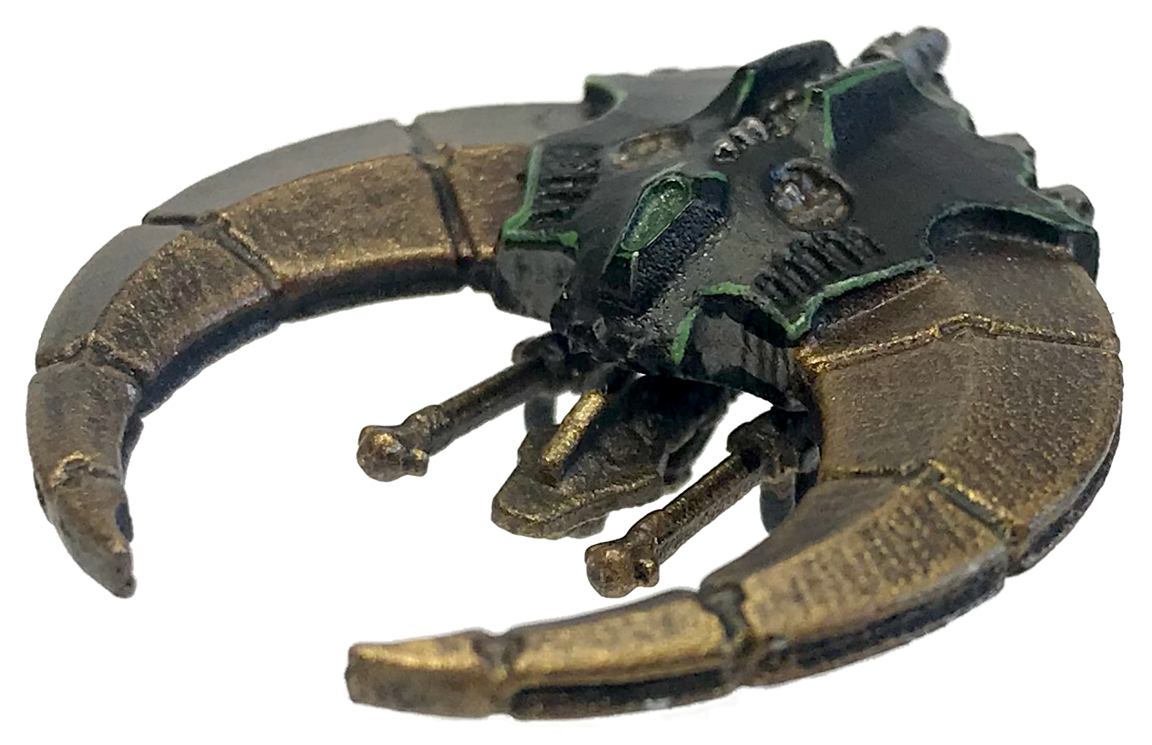
Doom Scythes are usually dropped from necron spaceships hovering on low orbit, unless they spring from the underground cache of a Tomb World complex. They carry a vast array of anti-infantry and anti-tank weapons, but no missile and no cannon relying on anything but pure energy. Lacking any need for shells and crewed by tireless pilots, Doom Scythes can patrol for extended periods.

- Flyer.

Night Scythes

Night Scythes bear a striking resemblance with Doom Scythes but their purpose is different. They trade part of the fighter armament for a wormhole gateway allowing a strike force of necron to be released from a pocket dimension right in the middle of enemy lines – an original necron tactic to silence anti-aircraft batteries.

- Flyer.
- Transport (1 stand of cavalry, 2 stands of jump pack infantry or 3 stands of regular infantry.)
- Wormhole: Flying at low altitude, Night Scythes may unload their troops in mid-flight using their special Wormhole portal. The Wormhole allows an alternate method for disembarking troops. When using the Wormhole, place a barrage template along the path of a Night Scythe model at the end of its movement: transported stands are placed on this template, with Advance Orders and a 5cm movement penalty as if they exited a Portal.

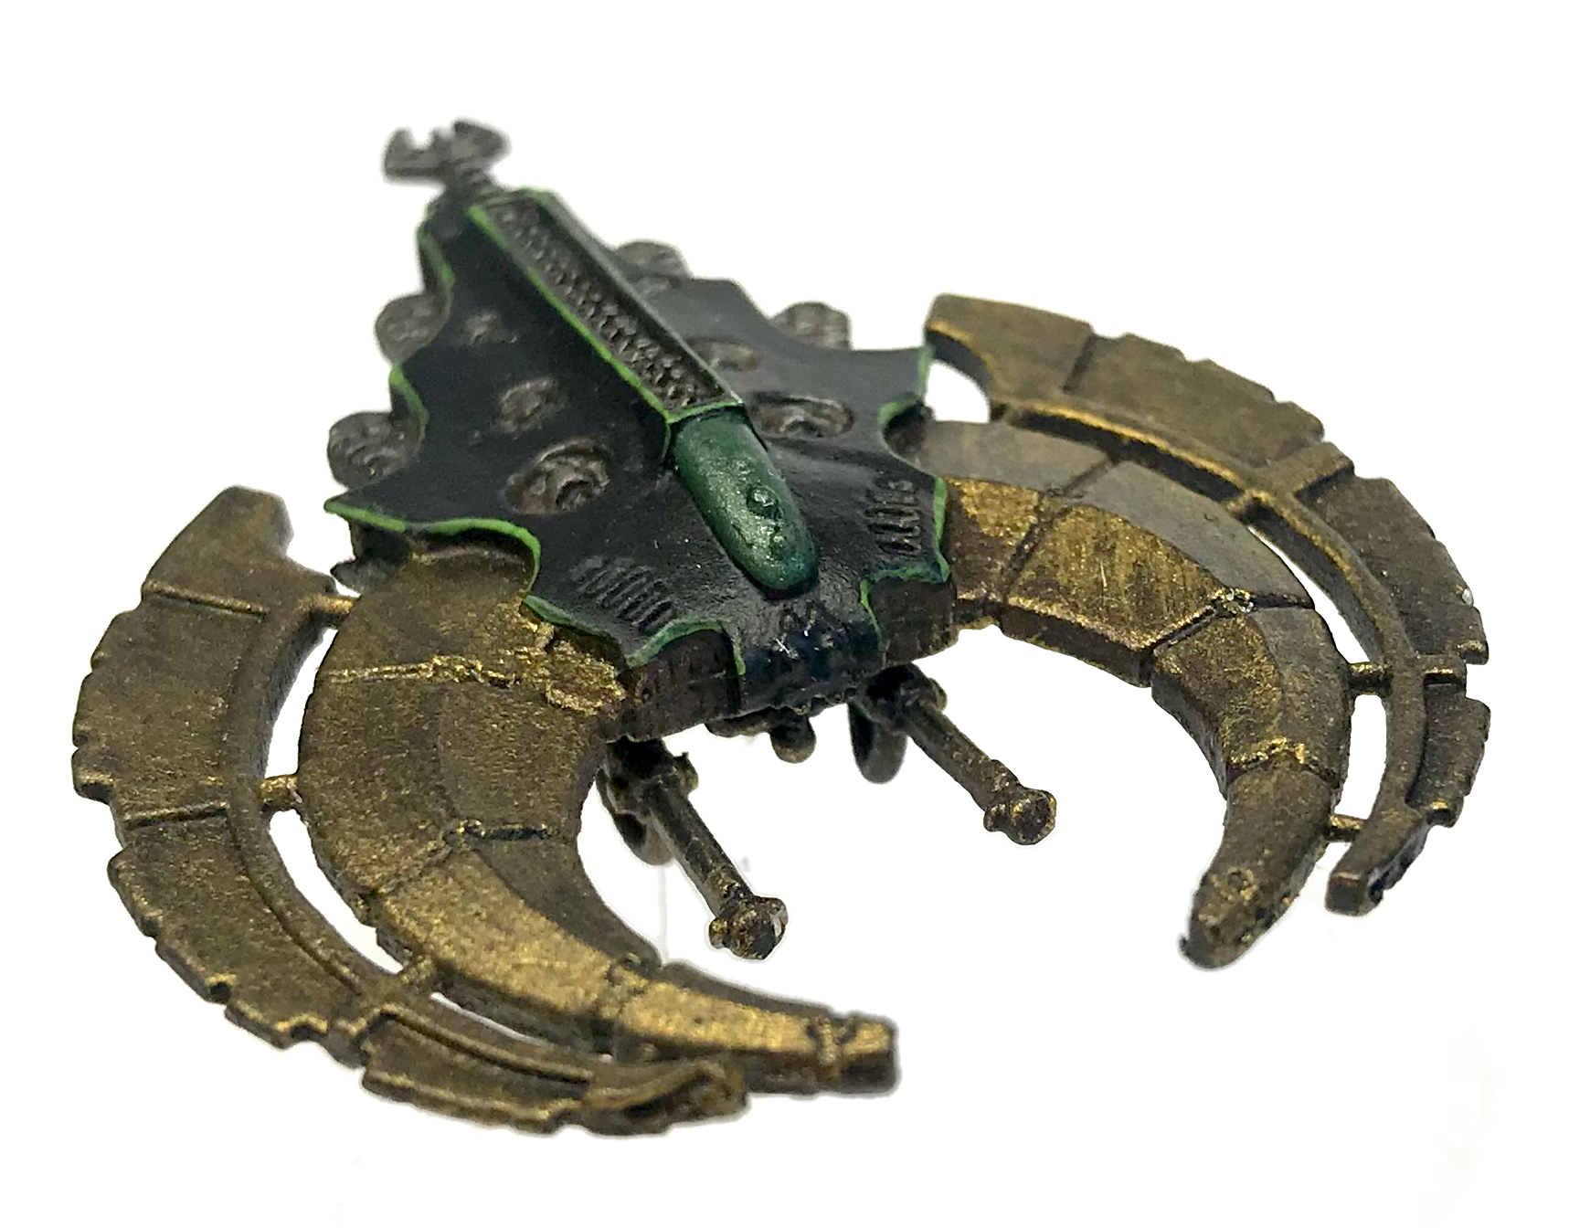
Night Shroud Bombers

Night Shroud Bombers are based on the same airframe as Doom and Night Scythes, but carry a devastating weapon known as a Death Sphere. This weapon is deployed as the Night Shroud strafes its ground-based target, and can lay waste to entire detachments of infantry.

- Flyer.
- Death Sphere: this weapon is used during the Night Shroud’s movement phase. Follow the “Drop Things” special rule for Floaters.

Super-Heavies

Monoliths
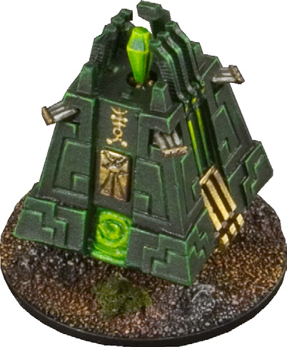
The Monolith is often the first and most frightening sight of a necron invasion. This huge pyramid-shaped war engine far more dangerous than it seems for its Portal is an exit gate for necron legions.

- All-Around Armor.
- Heavy Skimmer: the Monolith moves as a Skimmer but is unable to perform pop-up attacks.
- Particle Whip: this turret-mounted weapon has two fire modes, spread or focused. It can’t use both in a single turn.
- Point Defence (4).
- Portal (Infantry).
- Teleport.

Pylons

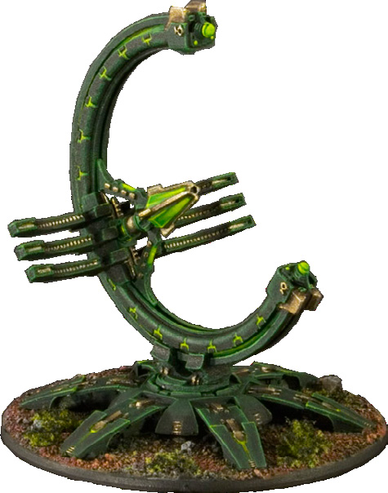
These huge defence platforms are spread through the galaxy and appear like harmless ruins or stay buried in the ground until they activate. When they do so, the planet is ready for harvest, being cut down from any external help – for Pylons are ultimate anti-aircraft units, able to take down even low orbiting spaceships.

- Anti-Aircraft.
- All-Around Armor.
- Heavy Skimmer: The Pylon moves as a Skimmer but is unable to perform pop-up attacks.
- Slow: Pylons move only in a limited manner. They can move up to 10cm on Charge Orders only.
- Point Defence (6).
- Teleport.

Canoptek Stalkers

Canoptek Stalkers, or Tomb Stalkers, are huge worm-like constructs sharing the same phasing technology than Canoptek Wraiths, but similarities stop there. Their sole purpose is to track and destroy invaders before they even discover a buried Necropolis. They relentlessly crawl underground through layers of solid rock and strike as soon as they sense life. Once a Tomb World is awakened, though, they remain a tool of choice for a Phaeron wishing to disrupt enemy lines.

- Localized Earthquake: The Stalker is able to unleash devastating vibrations at close range. The Localized Earthquake may always be fired in the Movement Phase when the Stalker has completed its movement (irrelevant to Stalker orders), and makes the Stalker appear at ground level if underground movement was chosen. Center a barrage template on the model: all units touched by the template are affected, except skimmers and flyers. The earthquake damages buildings. Once the attack is resolved, leave the template in place: the area count as rough terrain until end of turn. If different kinds of terrain overlap, use the worst movement penalty applicable.
- Tunneler.
- Underground Assault: Canoptek Stalkers often launch surprise attacks from underground. When a Stalker first comes in play, pick three non-HQ enemy Infantry stands at least 30cm apart and not in a transport. Number them 1, 2 and 3 then roll a D3: the Stalker erupts from the ground 1 cm away from the target, in a position chosen by the Necron player. If you can’t pick three valid targets or don’t want to, use regular Tunneler rules for deployment instead (including the D6 roll for possible delay). Regardless of the deployment method used, the Stalker may use its Localized Earthquake on the turn it appears.

Canoptek Sentinels

Canoptek Sentinels, or Tomb Sentinels, resemble Canoptek Stalkers, but have been modified by their Cryptek masters to carry a terrifying Exile Cannon in place of the Stalker’s head and mandibles.

- Tunneler.

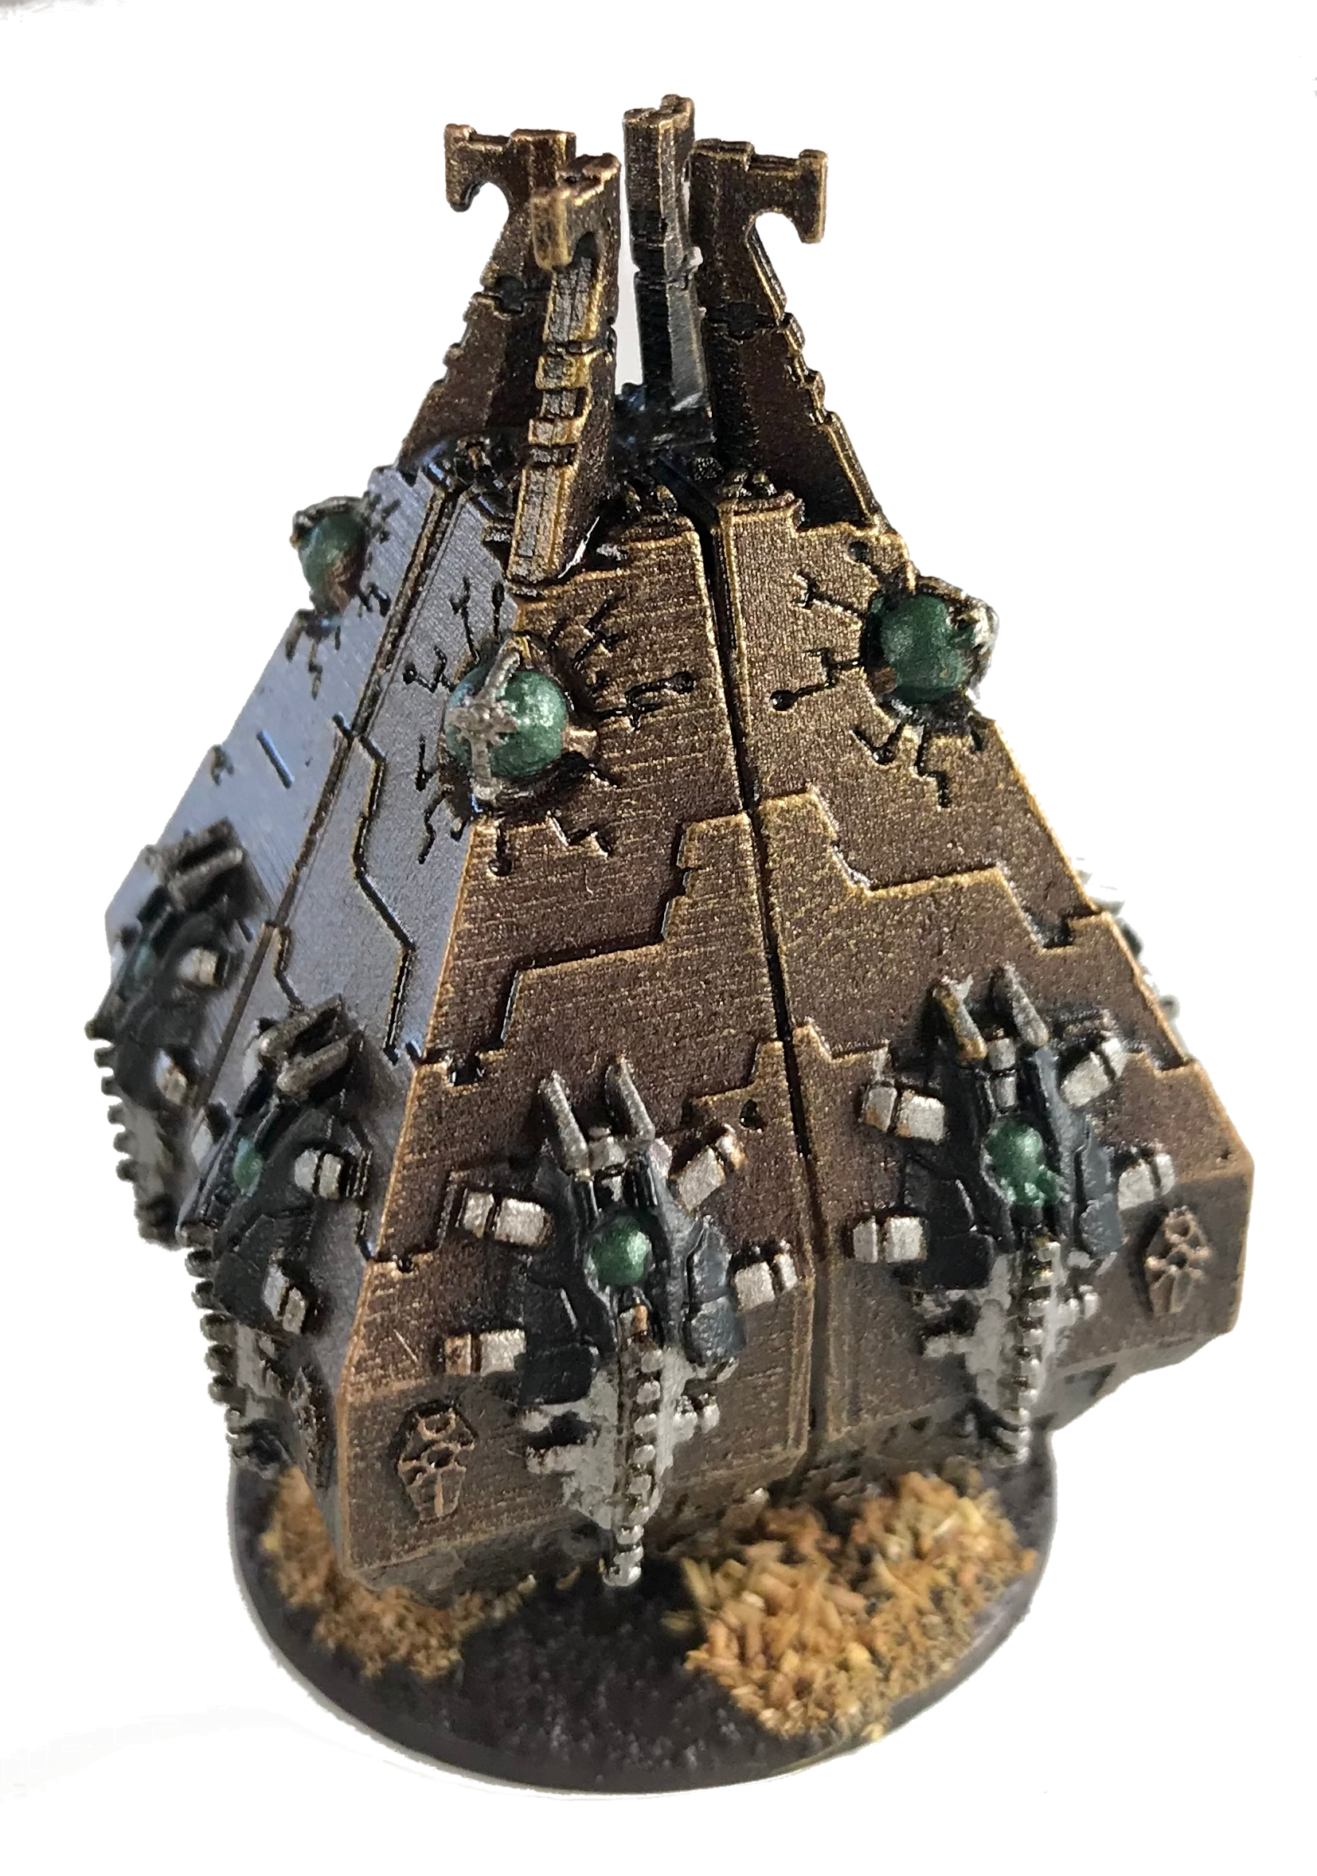
Tesseract Obelisk

Tesseract Obelisks stand watch over necron tomb complexes, watching the skies, reacting instantly to any aircraft that might threaten the peace of the necrontyr slumbering within. If a threat is detected, the Obelisks will unleash a devastating barrage of firepower from long range, destroying the target before it is even aware of the threat.

- Heavy Skimmer.
- Point Defence (6).
- Anti-Aircraft.

Tesseract Vault

Tesseract Vaults are immense constructs with a single purpose: to contain and control a C’tan Shard, which, once contained, is compelled to do the bidding of its necron controllers and produce astonishing levels of destructive power.

- Heavy Skimmer.
- Point Defence (6).
- Antimatter Meteor: this weapon uses the 12cm template.

Others

Scarab Swarms

Canoptek Scarabs are small beetle-like robots constantly repairing damaged necrons. Skimming silently in the empty corridors of Tomb World Necropolis, they number among the countless mechanical servitors necrons used for maintenance over the millennia. In times of war, they accompany their masters in battle and sometimes drown enemy units under their claws. Each necron infantryman is surrounded by thousands of mindless Scarabs, but they gather in buzzing clouds to achieve a cohesive goal only when directed to by a superior intelligence.

Scarab Swarms are purchased as Support Cards but are worth 0 VP. They bring in two Scarab counters that can be used by any Canoptek Spyder model or infantry stand in the army (regardless of the Company they have been purchased for). The Necron player doesn’t need to allocate Scarab Swarm counters beforehand; the model benefiting from the Scarabs is decided only when the Necron player chooses to use one. Scarabs have no real location, and can’t be destroyed, even by Phase Out. Each counter can be used in two ways:

- Assault: at the beginning of its activation in the Shooting Phase, choose a Necron infantry stand or a Canoptek Spyder model and spend a Scarab counter: the model directs Scarabs to attack the enemy. In addition to its ranged weapons, it gains a one-shot barrage of 4 BP and a range of 25cm, ignoring cover and with 0 TSM. A given stand or model can only benefit from one Scarab counter per turn this way.

- Repair: whenever an infantry stand failed its fixed save, gamble a counter to grant the stand a special “repair” save of 4+. This save is not modified by the TSM of the attack and can be attempted only once per hit. The scarab counter is spent only if the save succeeds. This ability can be used only on Necron infantry stands featuring a fixed save.

Summoning Cores
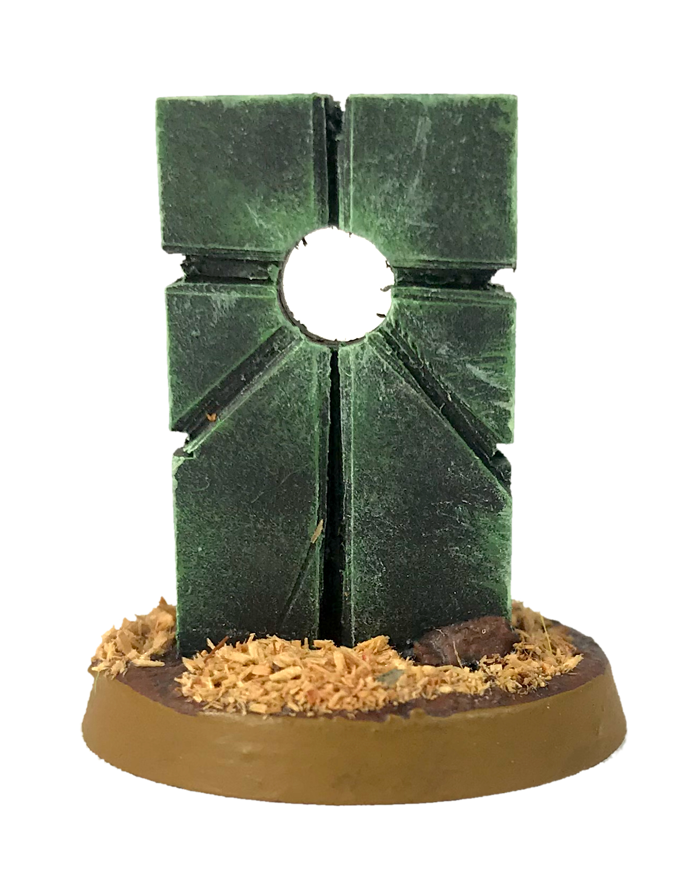
The Summoning Core forms the nexus of an intangible necron teleportation grid, allowing infantry units to relocate to any Summoning Core on the battlefield, as well as providing the necessary focal point for the resurrection of more advanced necron soldiers. Necron Warriors and Wraiths can also channel energy through this network to dramatically increase their own power.

- Stationary: Summoning Cores are stationary and cannot move. However, they may begin the game off- table and be teleported to a location of the player's choice (subject to normal Teleport rules).

- Portal: Any Necron infantry units may use a Summoning Core as a Portal as per the normal Portal rules.

- Summoning Core: All Necron Warrior units within 15cm of a Summoning Core receives a +1 bonus to its Saving Throw. All Necron Wraith units within 15cm of a Summoning Core gain a +1 bonus to their CAF.

Titans & Praetorians

Necron Titans and Praetorians can wreak havoc while absorbing a disheartening amount of return fire. They all share the following special abilities:

- Agile.

- Heavy Skimmer: Titans and Praetorians move as Skimmers but are unable to perform pop-up attacks.

- Living Metal. Consult each model’s reference sheet for the number of Living Metal points it has.

- Psychic Save (4+).

- Reinforced Necrodermis: The Necrodermis used for Necron Praetorians is threaded with filaments of phase-hardened amaranthite and other alloys of extreme resistance. The damage roll bonus given by Penetrating (+X) weapons is ignored against Reinforced Necrodermis; treat these hits as regular hits instead. Other special damage-dealing abilities, like grab attacks, retain their full effect.

Tomb Warden
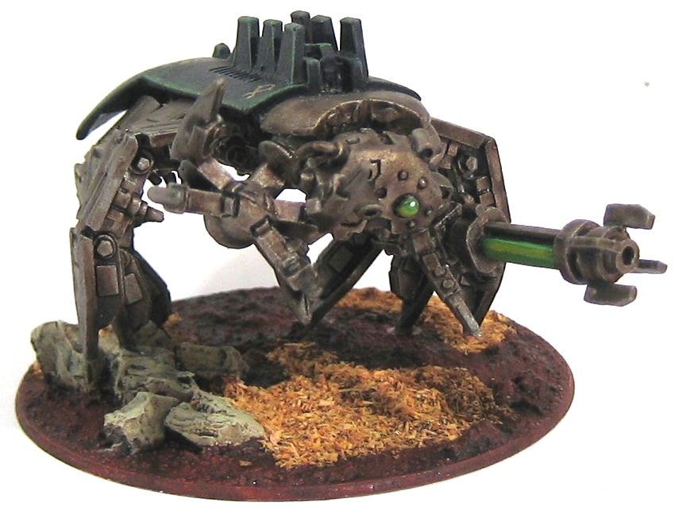
Tomb Wardens appears as a giant Canoptek Spyders armed with claws and larger versions of the Particle Projector. They are the most frequent war machines employed by necrons. Activated when a Necropolis is threatened by Gargants or other Titan-class foes, they stay active until the Tomb World fully awakes, waiting for a necron lord to submit to.

The Gauss Blaster and Conversion Beam cannon have a 180° fire arc to the front of the Tomb Warden.

- Gauss Blaster: the weapon combines a Gauss Weapon with a Power Claw. The Gauss Blaster may be fired in the Shooting Phase or used as a Power Claw in close combat, but not both in the same turn. When winning a Close Combat, the Power Claw allows a grab attack at +1 against a Titan / Praetorian.

If the player wishes to make a grab attack, he must select a damage table from the damage location chart and roll a D6 with a +1 modifier. The defending player rolls a D6 with no modifier. If the Tomb Warden scores higher, the location the player selected receives the most damaging result. If the result is a tie the defender has slipped out of the grasp but receives normal damage (resolve normally by rolling once on the damage table for that location). If the defenders score is higher, it has broken free and receives no damage. A Tomb Warden in base-to-base contact with buildings may elect, in addition to normal attacks, to hit the building once. The building must make a save at -4 TSM or be destroyed.

- Conversion Beam Cannon: the power of the Conversion Beam is random, hinting that the Beam may not be designed for battle, or that Tomb Wardens did not pass through ages unscathed. After each hit, roll a die to know the TSM of the attack. Each attack die has its own TSM, even if they hit the same target.

Warbarque

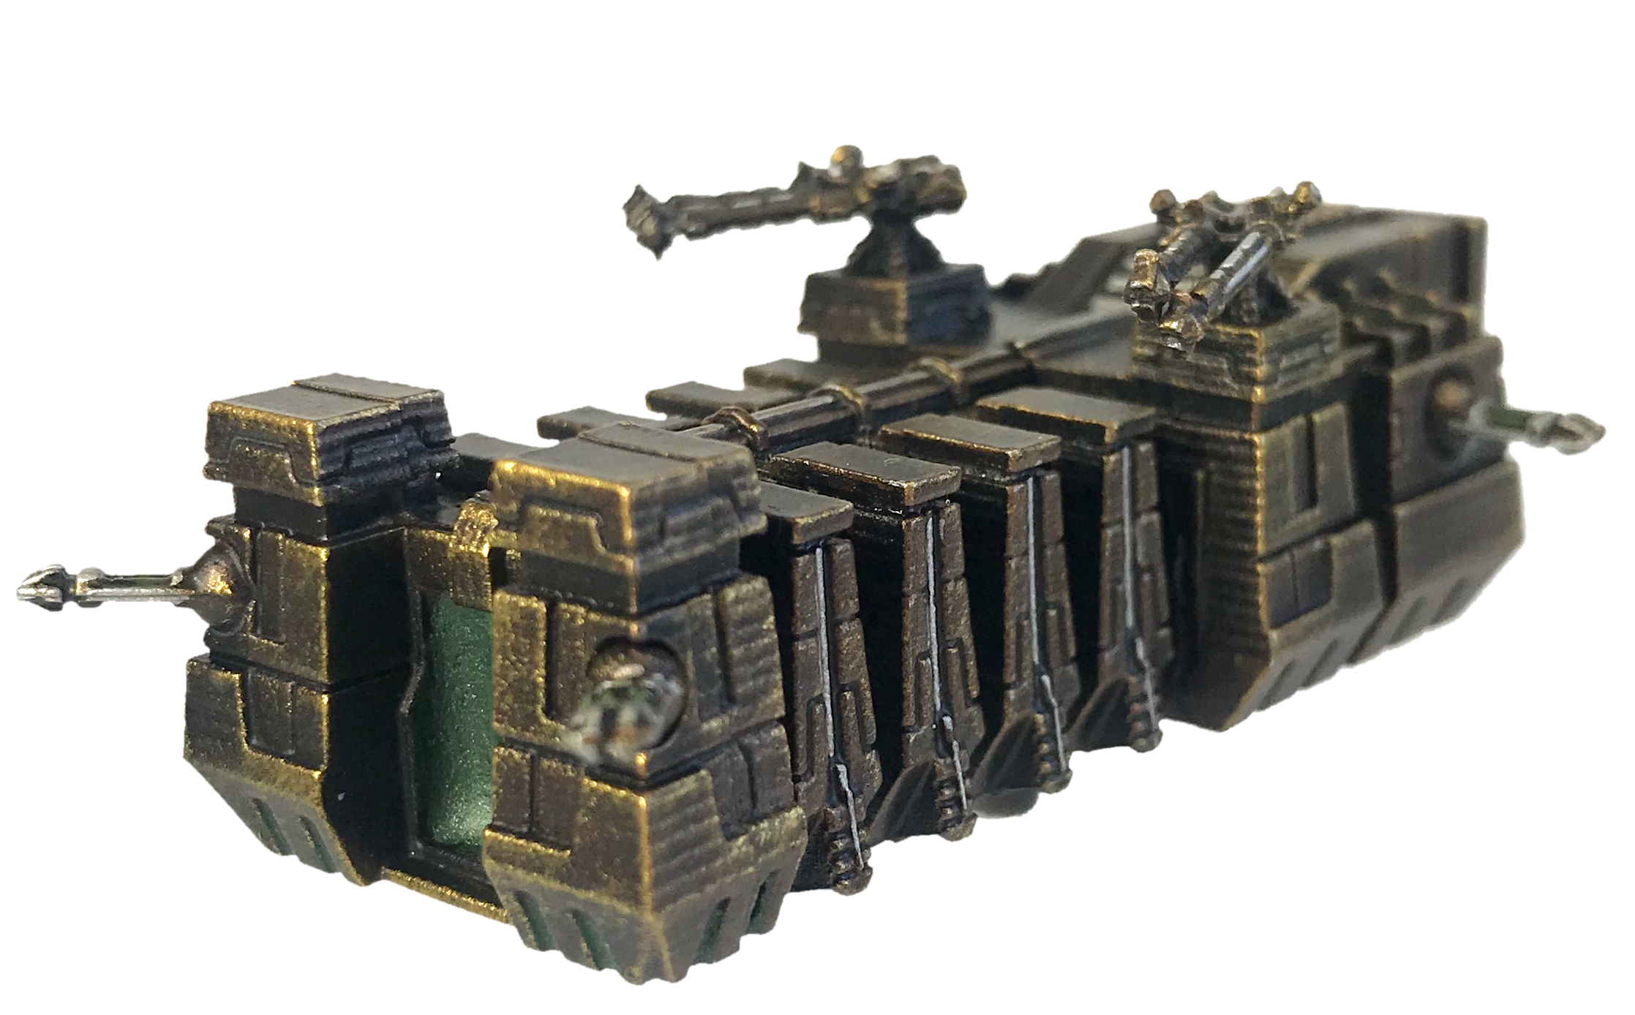
The Warbarque is a rare occurrence in necron armies, used only for full-scale invasion of a world. The Warbarque is a miracle of technology, able to teleport itself and carrying a large Portal, acting as an entry point for a complete necron force. The very existence of the Warbarque proves that no world is out of reach from necrons.

- Dimensional Shift: the Warbarque is able to extend the rift in reality as it appears. The Dimensional Shift may only be fired once per battle on the turn the Warbarque appears through Teleportation. It can’t be fired if the Warbarque doesn’t use Teleportation. The Dimensional Shift is fired in the First Fire segment.
- Engine of Destruction: only one Engine of Destruction Praetorian is allowed in a Necron army.
- Portal (Super-Heavies).
- Teleport.

Abattoir
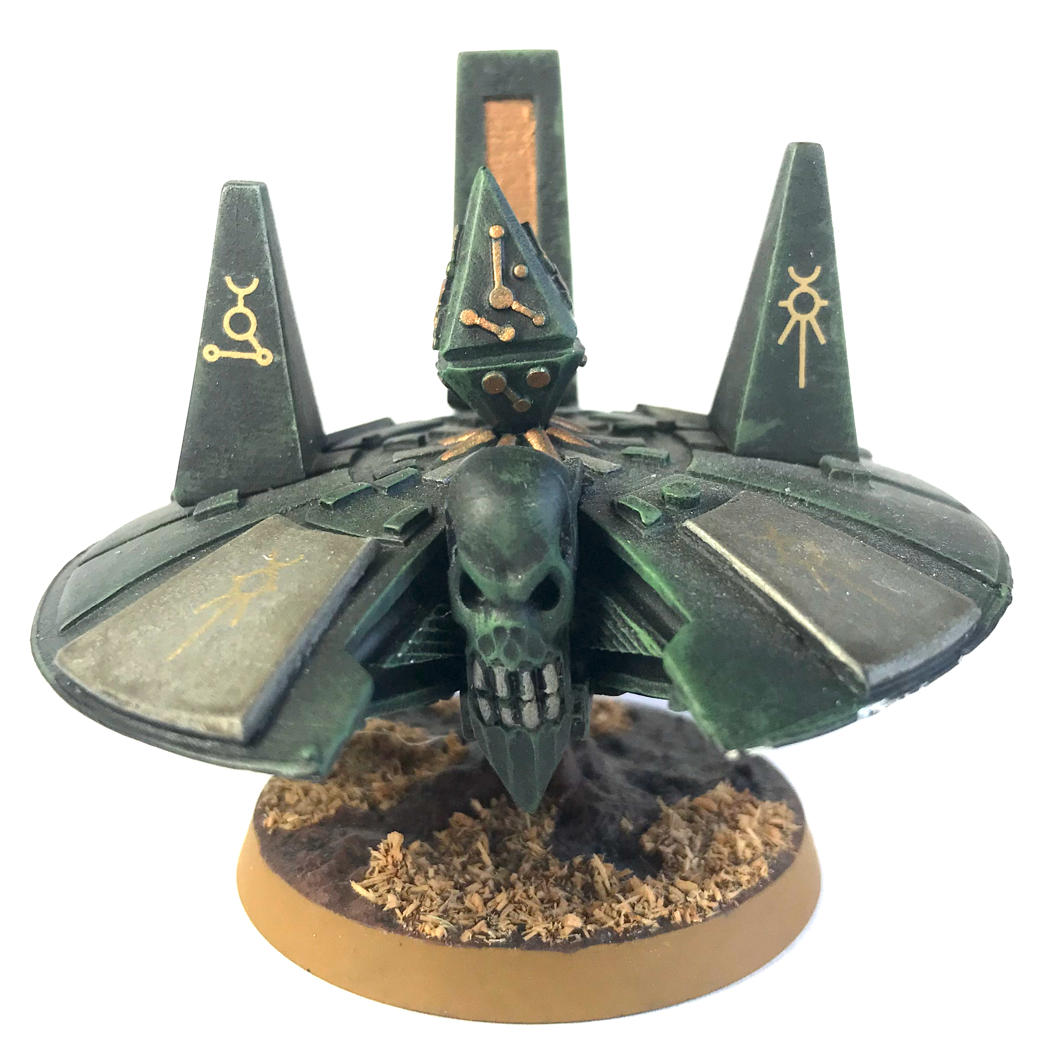
The Abattoir is a structure massive beyond relief, transported on worlds necrons have decided to “harvest”. Dropping from low orbit, it looks like a floating pyramid with thousands of tentacles underneath. The Abattoir is exceedingly rare since it is one of the few relics from the war against the Old Ones. An activated Abattoir is a terrifying sight, drifting over the ground while its tentacles rip and fire energy beams on all living things.

The Abattoir has the same location template for front, sides and rear.

- Deep Strike.

- Engine of Destruction: only one Engine of Destruction Praetorian is allowed in a Necron army.

- Harvesters: the tentacles covering the underneath of the Abattoir make up a single weapon known as the Harvesters, ignoring cover, with 18 attack dice. More than one attack die may be allocated to target(s) only if all eligible targets in range have received one attack die. While Harvesters are active, the Abattoir can’t be outnumbered by anything smaller than a Titan. Smaller units do not generate additional Close Combat dice for fighting the Abattoir together. Moreover, Harvesters can neutralize a single weapon from each Titan-sized opponent the Abattoir is in contact with before the combat begins. The weapon is chosen by the Necron player and may be a ranged weapon or a close combat weapon. If the Abattoir wins, the Necron player is granted an additional damage roll on the weapon table. Both damage rolls are at +2. All those abilities are lost if Harvesters attack dice are reduced to 0. Harvesters have a 360° arc of fire.

- Portal (Cavalry): see Necron special rules. The Abattoir features four Portals, one on each side.

- Scarab Swarms: The Abattoir can fire three barrage templates a turn with a 360° arc of fire. Those barrages are resolved separately, and templates do not need to touch each other. They ignore cover.

- Sniper. The Abattoir senses life and few can hide from it.

Æonic Orb

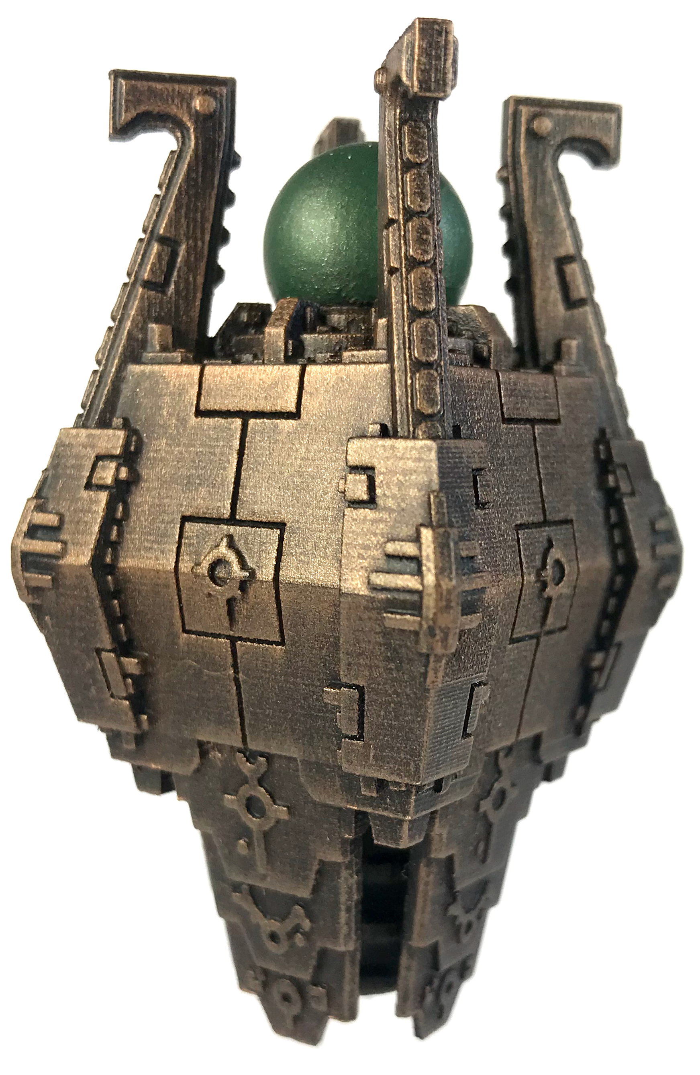
The Æonic Orb is so rare that its existence is only a rumour. The epitome of necron technology, it is supposed to hold the power of a star in a containment chamber, the structure being carried by an anti-grav platform. A small opening in the field is enough to hurl a stream of plasma annihilating anything along its path. Scholars can only speculate over the targets the Orb has been designed to destroy.

- Engine of Destruction: only one Engine of Destruction Praetorian is allowed in a Necron army.

- Plasma Chamber: The Æonic Orb starts the game with 3 plasma counters in its Plasma Chamber (the maximum). The Æonic Orb regenerates 2 plasma counters in each End Phase. Those counters are used to fire the Solar Flare and to power the Solar Burst. Unused plasma counters may be used on following turns.

- Solar Flare: The Solar Flare may fire multiple times as long as there are plasma counters available. Plasma counters may be distributed between shots: 2 counters for a shot and 1 for another, 3 for a single shot, etc. Counters may be saved for later. For each shot, check weapon profile accordingly:

Plasma Counters | Range | Attack Dice | To-Hit Roll | TSM | Additional effects
1 | 60cm | 1 | 3+ | -4 | Pulse Level. Damages Buildings. Penetrating (+1).
2 | 120cm | 1 | 2+ | -6 | location template, inflicts 4 additional impacts on adjacent locations (right, up, left, down) at -3 TSM.  Each impact downs a shield Resolve centre last. Penetrating (+1) against all locations.
3 | 180cm | 2 | 2+ | -6 | Maximum Level. As Focused, but with two attack dice (and therefore up to 10 impacts). Attack dice must be allocated to the same target.  Against a hit location template, any successful hit from the Solar Flare (bypassing any eventual fixed save like a holo-field) translates into five impacts in a cross-shaped area. Each impact is resolved separately and downs one shield or force field, etc. If the template is reached, roll deviation for the centre of the cross and proceed in the following order: right, up, left, down, and centre last. For example, if target had 3 void shields, “right, up and left” impacts are negated by shields (even if deviation shows some of them would have landed on an empty space) and only “down” and “centre” impacts are resolved. Edges of the cross have -3 TSM; centre has -6 TSM and is always resolved last. The weapon is Penetrating (+1) against all locations. The Solar Flare has an arc of fire of 180° to the front.

- Solar Burst: the Æonic Orb is able to fire a controlled spray of plasma on a wide zone. The Solar Burst may be fired after all Solar Flare attacks have been resolved and only if there is at least one plasma counter left in the Plasma Chamber, but firing the Solar Burst costs no plasma counter. The Solar Burst fires only once per turn. The weapon ignores to-hit modifiers for cover and has an arc of fire of 180° to the front.

Tomb Warden Titan Template

Move | CAF | Living Metal Score | Self-Repair | Notes
25cm | +10 | 2 | 3+ | Agile, Heavy Skimmer, Living Metal, Psychic save (4+), Reinforced Necrodermis

Tomb Warden weapons have a 180° arc of fire to the front of the Titan. Gauss Blaster may be fired in the Shooting Phase or used as a Power Claw in close combat, but not both in the same turn. When winning a Close Combat, the Power Claw allows a grab attack at +1 against a Titan / Praetorian. A Tomb Warden in base-to-base contact with buildings may elect, in addition to normal attacks, to hit a building once. The building must make a save at -4 TSM or be destroyed.

Weapon | Range | Attack Dice | To-Hit | TSM | Notes
Gauss Blaster | 50cm | 6 | 5+ | -1 | May be used as a ranged weapon or as a Power Claw (grab attack +1) but not  both in the same turn.
Conversion Beam Cannon | 100cm | 2 | 4+ | -D6 | Roll for TSM after each hit.

FRONT | SIDE | REAR
Head  1+  Hull 2+ Hull 2+ Hull 2+  Weapon 2+ Hull 2+ Legs 2+ Hull 2+ Weapon 2+  Legs 2+ Legs 2+  Legs 3+ Legs 3+  Legs 4+ Legs 4+ | Head  2+  Hull 2+ Hull 2+ Hull 2+ Hull 2+  Legs 3+ Legs 3+ Weapon 3+ Weapon 2+  Legs 3+ Legs 3+ Legs 3+  Legs 3+ Legs 3+ Legs 3+  Legs 4+ Legs 4+ Legs 4+ | Head  3+  Hull 2+ Reactor 3+ Hull 2+  Weapon 4+ Hull 2+ Legs 4+ Hull 2+ Weapon 4+  Legs 4+ Legs 4+  Legs 4+ Legs 4+  Legs 4+ Legs 4+

 | Head | Reactor  1-2 Reactor damaged. The Tomb Warden may not move, fire or repair other damage until the reactor is first repaired.  3-4 Reactor damaged. If the reactor is not repaired in the End Phase, it explodes as 5-6 below.  5-6 Reactor explodes! The Tomb Warden is removed. All models within 2D6 cm are automatically hit and must make an unmodified save to avoid destruction.
1-2 | Sensors damaged. Until repaired, the Tomb Warden CAF  is +5 and it may only move or fire if you roll a 4+ on a D6.
3 | Sensors damaged. CAF is now +5 for the rest of the game  and the Agile ability is lost.
4-5 | Sensors blown off. The Tomb Warden CAF is now +5  and it may only move or fire if you roll a 4+ on a D6. Agile ability is lost.
6 | Head explosion. The Tomb Warden collapses. Roll a scatter die for direction and determine which units are underneath. Knight-class and larger models take a hit at -3  TSM, and smaller units are destroyed with no save.
 | Weapon | Legs  1-2 Leg actuator damaged. Speed drops by 5cm until damage is repaired.  3-4 Leg actuator disabled. Speed drops by 5cm permanently.  5-6 Leg crippled. Tomb Warden may not move anymore but only turn on spot. If the Tomb Wardens suffers three “Leg crippled” results, it falls to the ground and is destroyed.
1-2 | Weapon damaged. The weapon cannot fire until it is
 | repaired.
3-4 | Weapon destroyed.
5 | Weapon is blown off the Tomb Warden and scatters
 | 2D6 cm in a random direction. Any models it hits must
 | make an unmodified save to avoid destruction.
6 | Same as 5, but there is a flashback to the Tomb Warden’s
 | hull. Roll for damage on the Hull table.
 | Hull
1-7 | Hull is weakened. Add +1 to any further damage rolls against the Hull.
8+ | A massive explosion rips a huge hole in the Hull, destroying the Tomb Warden.

Warbarque Praetorian Template

Move | CAF | Living Metal Score | Self-Repair | Notes
20cm  max | +8 | 3 | 4+ | Agile, Heavy Skimmer, Living Metal, Psychic save (4+), Portal (Super-Heavy), Reinforced Necrodermis, Teleport

Warbarque weapons have a 360° arc of fire. The Dimensional Shift is a one-shot weapon that can only be fired the turn the Warbarque is brought into play through Teleportation. It can’t be fired if the Warbarque doesn’t use Teleportation. The Dimensional Shift is fired in the First Fire segment.

Weapon | Range | Attack Dice | To-Hit | TSM | Notes
Turret-mounted Gauss Cannon | 50cm | 3 | 4+ | -2
Electro-Hull | 15cm | 4 | 6+ | 0 | Ignores covers
Dimensional Shift | 10cm | 6 BP | 4+ | -3 | Fired in the FF segment when the Warbarque appears, one-shot weapon

FRONT SIDE REAR
 | Bridge 1+
Hull  2+ | Hull  2+ | Hull  2+
Hull  2+ | Portal  3+ | Hull  2+
Hull  2+ | Portal  3+ | Hull  2+
Hull  2+ | Anti-G  2+ | Hull  2+

Bridge 3+
Hull  3+ | Hull  3+ | Hull  3+ | Hull  3+ | Hull  3+
Hull  3+ | Hull  3+ | Hull  3+ | Hull  3+ | Portal  4+
Anti-G  4+ | Anti-G  3+ | Hull  3+ | Hull  3+ | Portal  4+
Anti-G  4+ | Anti-G  3+ | Hull  3+ | Hull  3+ | Hull  3+

 | Bridge 4+
Hull  4+ | Hull  4+ | Hull  4+
Hull  4+ | Anti-G  4+ | Hull  4+
Anti-G  4+ | Anti-G  4+ | Anti-G  4+
Anti-G  5+ | Anti-G  5+ | Anti-G  5+

 | Bridge | 1-2  3-5  6 | Anti-Grav System  Speed drops by 10cm.  The Warbarque falls to the ground. It can no longer move and does not count as a skimmer anymore. If the Warbarque was hovering over impassable terrain, treat this as 6 instead. Further damage to the Anti-Grav System is rolled on the Hull table instead.  The Warbarque crashes spectacularly and is destroyed.
1-2 | The Warbarque’s AI is confused. Turn the Warbarque in a  random direction. It may not move until repaired.
3-4 | Targeting system damaged. Until repaired, the Warbarque  can only fire its Electro-Hull.
5-6 | Bridge destroyed. The Warbarque moves 2D6 cm in a  random direction then explodes. Any model under its final location suffers a single hit with no TSM.
 | Hull |  | Portal
1-7 | Hull is weakened. Add +1 to any further damage rolls against the Hull. | 1-22 | Generator damaged. The Portal may not be used until repaired.
8+ | A massive explosion rips a huge hole in the hull, destroying the Warbarque. | 3-44 | Generator shut down. The Portal may not be used anymore.  Roll further damage for this location on the Hull table instead.
 |  | 5-66 | The frame of the Portal breaks, letting loose the dimensional gate. The Warbarque implodes and its remnants get absorbed in the portal before it closes. Any vehicle or troop stand within 2D6 cm is hit on a 4+ and sucked into the portal too (no save!) Larger models are  unaffected.

Abattoir Praetorian Template

Move | CAF | Living Metal Score | Self-Repair | Notes
20cm  max | +16 | 4 | 4+ | Agile, Deep Strike, Heavy Skimmer, Living Metal, Psychic save (4+), Portal (Cavalry), Reinforced Necrodermis, Sniper

Abattoir weapons have a 360° arc of fire. More than one attack die may be allocated to a target only if all eligible targets in range have received one attack die. Harvesters prevent the Abattoir to be outnumbered by anything smaller than Titans or Praetorians. Smaller units do not generate additional Close Combat dice for fighting the Abattoir together. Moreover, Harvesters can neutralize a single weapon from each Titan-sized opponent the Abattoir is in contact with before the combat begins. The weapon is chosen by the Necron player and may be a ranged weapon or a close combat weapon. If the Abattoir wins, the Necron player is granted an additional damage roll on the weapon table. Both damage rolls are at +2. All those abilities are lost if Harvesters are reduced to 0 attack dice. The Abattoir features four portals, one in each face.

Weapon | Range | Attack Dice | To-Hit | TSM | Notes
Harvesters | 20cm | 18 | 3+ | -1 | Ignores cover, see special rules
Scarab Swarms | 25cm | 4 BP | 5+ | 0 | Ignores cover, fires three times a turn

FRONT / SIDE / REAR

Crystal
1+
 |  |  | Hull  1+ | Hull  1+ | Hull  1+
 | Hull  1+ | Hull  1+ | Hull  1+ | Hull  1+ | Hull  1+ | Hull  1+ | Hull  1+
Hull  1+ | Hull  1+ | Hull  1+ | Hull  1+ | Hull  1+ | Hull  1+ | Hull  1+ | Hull  1+ | Hull  1+
Weapon  2+ | Weapon  2+ | Weapon  2+ | Weapon  2+ | Portal  3+ | Weapon  2+ | Weapon  2+ | Weapon  2+ | Weapon  2+

 | Crystal | Portal
1-2  3-4 | Temporary blindness. The Abattoir is unable to decide where it should continue the harvest. The Abattoir may not move until the damage is repaired.  Fissure. As 1-2 above. Automatic repair systems struggle to fill in the crack before it widens under the pressure of the immense energy contained within the Crystal. If the fissure  is not repaired in the End Phase, it becomes a split as 5-6 below. | 1-4 The Portal on this side is destroyed. Roll further damage for this location on the Hull table instead. If the Portal was the last active one of the Abattoir, the delicate field machinery implodes. Roll on the Inner Chamber table.  5-6 As 1-4 above but a chain reaction occurs. Roll for damage again for an active Portal located in another side. Decide  randomly if more than one Portal is eligible.
Inner Chamber
1-2 | Energy shutdown. Command ability lost. The Abattoir CAF is reduced to +8 for the rest of the game and its repair roll becomes 6.
3-4 | The Abattoir enters in a fatal frenzy and attacks every model within 20cm, friend or foe, with a single Harvester attack die (if the weapon has any attack dice left). Then it crumbles on the ground. Replace the Abattoir with a ruin.
5-6 | The Abattoir explodes spectacularly. All models within 2D6 cm are hit automatically and must make a save at -2 to avoid destruction. All buildings in the area are destroyed. Replace the Abattoir with a crater.

5-6 | Split. The Crystal conveys an energy burst deep in the core  of the Abattoir. Roll on the Inner Chamber table.
 | Weapon
1-2 | Scarab Generator malfunctions. The Abattoir cannot fire  Scarab Swarms until the damage is repaired.
3 | Scarab Generator destroyed. The Abattoir cannot fire Scarab  Swarms anymore.
4-5 | Harvesters malfunction: Harvesters lose 6 attack dice (cumulative). Each “Harvesters malfunction” result may be repaired in the End Phase, restoring 6 attack dice to the  Harvesters.
6 | Harvesters crippled. The Harvesters lose 6 attack dice permanently. If Harvester attack dice were already at to 0 when getting this result, roll for damage once on Inner  Chamber table.
1-7  8+ | Hull  Hull is weakened. Add +1 to any future damage rolls against the Hull.  A massive explosion shakes the Abattoir and damages the Inner Chamber. Make a roll on the Inner Chamber table

Æonic Orb Praetorian Template

Move | CAF | Living Metal Score | Self-Repair | Notes
20cm  max | +10 | 3 | 4+ | Agile, Heavy Skimmer, Reinforced Necrodermis, Living Metal, Psychic save (4+)

Æonic Orb weapons have a 180° arc of fire to the front. The Æonic Orb starts the game with 3 plasma counters in its Plasma Chamber (the maximum). The Æonic Orb regenerates 2 plasma counters in each End Phase. Those counters are used to fire the Solar Flare and the Solar Burst. The Solar Flare can fire multiple times as long as there are plasma counters available. You can distribute plasma counters between shots as you wish: 2 counters for a shot and 1 for another, 3 for a single shot, three shots with 1 counter each, etc. You may save counters for later turns.
For each shot, check the weapon profile accordingly to the number of plasma counters spent.
The Solar Burst fires once, after all Solar Flare attacks have been resolved, and only if there is at least one plasma counter left in the plasma chamber.

Weapon | Plasma  Counters | Range | Attack  Dice | To-Hit | TMS | Notes
Solar Flare | 1 | 60cm | 1 | 3+ | -4 | Pulse Level. Damages Buildings. Penetrating (+1).
 | 2 | 120cm | 1 | 2+ | -6 | Focused Level. Destroys Buildings. Against a hit location template, inflicts 4 additional impacts on adjacent locations (right, up, left, down) at -3 TSM. Each impact downs a shield Resolve centre last. Penetrating (+1) against all locations.
 | 3 | 180cm | 2 | 2+ | -6 | Maximum Level. As Focused but shoots twice. Attack dice must be assigned to the same target.
Solar Burst | 0* | 30cm | 10 BP | 2+ | -2 | Ignores cover. *Requires a plasma counter in the Plasma Chamber. No counter is spent. The Solar Burst fires only once per turn.

FRONT | SIDE | REAR
Field  3+  Field 3+ Field 3+ Field 3+  Field 3+ Field 3+ Field 3+  Ring 1+ Ring 1+ Ring 1+  Base 2+ Base 2+ Base 2+  Base 2+ | Field  3+  Field 3+ Field 3+ Field 3+  Control 4+ Field 3+ Field 3+  Control 4+ Ring 1+ Ring 1+  Base 2+ Base 2+ Base 2+  Base 2+ | Field  3+  Field 3+ Field 3+ Field 3+  Field 3+ Control 5+ Field 3+  Ring 1+ Control 5+ Ring 1+  Base 2+ Base 2+ Base 2+  Base 2+

Containment Field  1-3 Minor power leak. Until repaired, the Solar Flare may not fire at Maximum Level.  4-5 Major power leak. Until repaired, the Solar Flare may only fire at Pulse Level.  6 Field Breach. The Plasma Chamber of the Solar Flare is depleted. All remaining plasma counters are lost. A burst of plasma engulfs the Æonic Orb. Roll for damage on the Power Ring table. | Power Ring  1-2 Misalignment. The Solar Flare suffers a -2 penalty on all To-Hit Rolls until the damage is repaired.  3-4 Weakened Field. From now on, the Solar Flare regenerates only 1 plasma counter in each End Phase.  5-6 The Ring races out of control and the Æonic Orb explodes. The field shuts down and plasma is unleashed in all directions. Each model within 2D6 cm is hit on a 5+ and must save at -3 TSM to avoid destruction.
Skimmer Base  1-3 Stabilizers hit. Weapon ranges halved until repaired.  4 The Orb cannot move until damage is repaired.  5 The Orb falls to the ground before emergency systems are able to take over. It is destroyed.  6 The Orb wanders out of control 2D6 cm in a random direction then crashes. Knight-class and larger models under its final location take a hit at -3 TSM; smaller units are destroyed with no save. | Orb Control  1-2 Secondary controls destroyed. The Orb cannot fire the Solar Burst anymore.  3-4 Primary controls destroyed. The Orb cannot fire the Solar Flare anymore.  5-6 Generators destroyed. The Power Ring comes to a grinding halt. The Æonic Orb dwindles to the ground as its anti-grav system fails. It is destroyed.

Necron Army Cards
Company Cards | Contents | Break Point | Morale | Victory Points | Cost
Campaign Legion | 1 Necron Lord on Command Barge  3 Eternal Phalanx | 28 | - | 15 | 1100
Warrior Legion | 1 Necron Lord  3 Warrior Phalanx | 19 | - | 10 | 700
Veteran Legion | 1 Necron Lord & 2 Lychguard stands  3 Immortal Phalanx | 14 | - | 12 | 900
Venator Legion | 1 Necron Lord  1 Warrior Phalanx  1 Immortal Phalanx  1 Monolith Triceps | 14 | - | 13 | 1000
Flesh-Eater Horde | 3 Flayed One Packs | 14 | - | 9 | 650
Destroyer Legion | 1 Destroyer Lord  1 Destroyer Eques  1 Heavy Destroyer Eques | 13 | - | 10 | 700
Monolith Egressor | 2 Monolith Triceps | 5 | - | 12 | 850
Pylon Triceps | 3 Pylon Vigilis | 2 | - | 7 | 650
Obelisk Praecursor | 3 Obelisk Tetra | 9 | - | 11 | 800

Support Cards
Infantry
Canoptek Wraith Phalanx | 3 Wraith stands | +2 | - | +2 | 150
Deathmark Phalanx | 4 Deathmark stands | +3 | - | +3 | 200
Eternal Phalanx | 8 Necron Warrior stands & 4 Ghost Arks | +9 | - | +5 | 350
Flayed One Pack | 6 Flayed One stands | 5 | - | 4 | 250
Immortal Phalanx | 6 Necron Immortal stands | +5 | - | +4 | 300
Pariah Phalanx | 4 Pariah stands | 3 | - | 4 | 250
Praetorian Phalanx | 4 Triarch Praetorian stands | +3 | - | +3 | 200
Warrior Phalanx | 8 Necron Warrior stands | +6 | - | +4 | 250

Cavalry
Canoptek Spyders | 2 Canoptek Spyder stands | +1 | - | +1 | 100
Destroyer Eques | 6 Destroyer stands | +5 | - | +4 | 250
Heavy Destroyer Eques | 4 Heavy Destroyer stands | +3 | - | +4 | 250
Tomb Blade Squadron | 4 Tomb Blade stands | +3 | - | +3 | 150
Canoptek Acanthrites | 5 Canoptek Acanthrite stands | +2 | - | +3 | 250

Walkers
Stalker Triceps | 3 Triarch Stalkers | +2 | - | +3 | 300

Vehicles
Annihilation Triceps | 3 Annihilation Barges | +2 | - | +3 | 250
Necron Lord on Command Barge | 1 Command Barge | +1 | - | +2 | 150
Doomsday Triceps | 3 Doomsday Arks | +2 | - | +4 | 400
Obelisk Tetra | 4 Obelisks | +3 | - | +4 | 300
Tesseract Ark Tetra | 3 Tesseract Arks | +2 | - | +4 | 350
Sentry Pylon Tetra | 3 Sentry Pylons | +2 | - | +3 | 300

Super-Heavies & Knights
Tomb Golem Triceps | 3 Tomb Golems | +2 | - | +3 | 250
Canoptek Stalker | 1 Canoptek Stalker | +1 | - | +1 | 100
Monolith Triceps | 3 Necron Monoliths | +2 | - | +5 | 450
Pylon Vigilis | 1 Necron Pylon | +1 | - | +3 | 250
Tesseract Vault | 1 Tesseract Vault | +1 | - | +5 | 450
Tesseract Obelisk | 1 Tesseract Obelisk | +1 | - | +5 | 450
Canoptek Sentinel | 1 Canoptek Sentinel | +1 | - | +1 | 100
Seraptek Heavy Construct | 1 Seraptek Heavy Construct | +2 | - | +2 | 200

Flyers
Doom Scythe Squadron | 3 Doom Scythes | +2 | - | +3 | 250
Night Scythe Squadron | 3 Night Scythes | +2 | - | +2 | 200
Night Shroud Bomber Squadron | 3 Night Shroud Bombers | +2 | - | +3 | 250

Other
Scarab Swarms | 2 Scarab Counters | - | - | +0 | 50
Summoning Core | 1 Summoning Core | Model | - | 2 | 150

Special Cards
Cryptek Covenant | 1 Cryptek stand | Cryptek stand | - | 1 | 100
Necron Overlord | 1 Necron Lord & 6 Lychguard stands | Necron Lord | - | 3 | 300
C’tan Shard | 1 C’tan Shard | Model | - | 5 | 500
Tomb Warden | 1 Tomb Warden Titan | Model | - | 5 | 450
Abattoir | 1 Abattoir Harvester Engine | Model | - | 9 | 900
Æonic Orb | 1 Æonic Orb | Model | - | 9 | 900
Warbarque | 1 Warbarque | Model | - | 4 | 400

Summary of Unit Statistics

Type | Move | Save | CAF | Weapons | Range |  | Attack Dice |  | To-Hit | TSM | Notes
Infantry
Cryptek | 10cm | 5+/6+f | 0 | Eldritch lance  Seismic Crucible* Ether Crystal | 75cm  50cm  25cm |  | 1  6 BP  4 |  | 4+  4+  5+ | -2  0  -1 | Command, Defence field, HQ, can use only one ranged weapon each turn  *Ignores cover, may fire indirect barrage
Canoptek Wraith | 30cm | 4+f | +4 | Shock Lash | - |  | - |  | - | - | Hard to hit, Jump packs
Deathmark | 10cm | 5+/6+f | +1 | Synaptic Disintegrator | 50cm |  | 1 |  | 5+ | -1 | Deathmark, Sniper, Teleport
Flayed One | 10cm | 5+/6+f | +3 | Claws | - |  | - |  | - | - | Fear, Infiltration, Outcasts
Lychguard | 10cm | 4+/5+f | +4 | Warscythe | - |  | - |  | - | - | Elite
Necron Immortal | 10cm | 5+/6+f | +1 | Gauss Blaster | 75cm |  | 2 |  | 5+ | -1
Necron Lord | 10cm | 4+/5+f | +4 | Staff of Light | 25cm |  | 2 |  | 4+ | -2 | Combat leader, Command, Elite, HQ
Necron Warrior | 10cm | 5+/6+f | +1 | Gauss Flayer | 50cm |  | 1 |  | 5+ | 0 | TSM -1 on a to-hit roll of 6
Pariah | 10cm | 5+ | +4 | Energy Bolt | 50cm |  | 2 |  | 5+ | -1 | Elite, Psychic abomination, Soulless
Triarch Praetorian | 15cm | 5+f | +5 | Rod of Covenant | 15cm |  | 1 |  | 5+ | -1 | Jump packs
Cavalry
Canoptek Spyder | 15cm | 4+ | +2 | None | - |  | - |  | - | - | HQ, Scarab generator, Skimmer
Destroyer | 30cm | 5+f | +2 | Gauss Cannon | 50cm |  | 2 |  | 5+ | 0 | Skimmer
Destroyer Lord | 30cm | 5+f | +5 | Warscythe | - |  | - |  | - | - | Combat leader, Command, Elite, HQ, Skimmer
Heavy Destroyer | 30cm | 5+f | +2 | Heavy Gauss Cannon | 75cm |  | 1 |  | 5+ | -2 | Skimmer
Tomb Blade | 30cm | 5+ | +1 | Tesla Carbines | 25cm |  | 3 BP@ |  |  | 0 | Hard to hit, Skimmer
Canoptek Acanthrite | 15cm | 4+ | +6 | Voidblades | 1 |  | 1 |  | 5+ | -1 | Skimmer
Walkers
Triarch Stalker | 40cm  max | 3+ | +3 | Heat Ray | 50cm |  | 1 |  | 4+ | -2 | Targeting relay
Vehicles
Annihilation  Barge | 30cm | 3+/5+f | 0 | Tesla Destructors  Tesla Cannon | 50cm  50cm |  | 6 BP |  | 4+ | 0  0 | PD(2), Skimmer
 |  |  |  |  |  |  | 4 BP@
Command Barge | 30cm | 3+/5+f | +5 | Tesla Cannon | 50cm |  | 4 BP |  | 5+ | 0 | Combat leader, Command, HQ, PD(2), Skimmer
Doomsday Ark | 20cm | 4+ | 0 | Doomsday Cannon*  (moving) | 120cm  50cm |  | 8 BP  4 BP |  | 3+  5+ | -4  -2 | PD(2), Skimmer  *90° fire arc
Ghost Ark | 20cm | 4+ | 0 | None | - |  | - |  | - | - | PD (2), Repair platform, Skimmer, Transport 2  (Necron Warriors only)
Obelisk | 30cm | 3+ All  Around | +2 | Flux Arcs* | 25cm |  | 4 |  | 5+ | -1 | Skimmer, Teleport  *Turret, Ignores Cover
Sentry Pylon | 10cm on charge | 2+ | +2 | Death Ray | 50cm |  | 4 |  | 4+ | -1 | Skimmer
Tesseract Ark | 20cm | 1+ | +2 | Singularity Chamber | 50cm |  | 8BP |  | 3+ | -2 | Skimmer, PD(2)
Knights
C’tan Shard | 30cm | 4+f All  Around | +8 | Psychic Trait* | - |  | - |  | - | - | Can sustain 6 damage, Command, Elite, Psychic  Save (2+), Psyker, Skimmer, *See rules
Seraptek Heavy Construct | 30cm | 2+ | +8 | 2x Singularity Generator | 75cm |  | 8BP |  | 3+ | -4 | Living Metal(1), PD(4), Hit & Run
Tomb Golem | 20cm | 3+f | +3 | Eldritch cannon | 50cm |  | 2 |  | 4+ | -3 | Attacks a single target, Penetrating (+1)
Flyers
Doom Scythe | 100cm | 3+ | +4 | Death Ray  Tesla Destructors | 25cm  50cm |  | 1  6 BP |  | 2+  4+ | -3  0 | Flyer
Night Scythe | 100cm | 3+ | +4 | Tesla Destructors | 50cm |  | 6 BP |  | 4+ | 0 | Flyer, Wormhole
Night Shroud Bomber | 100cm | 3+ | +4 | Death Sphere | - |  | 4BP |  | 4+ | -2
Super-Heavies
Monolith | 30cm  max | 1+ All  Around | +4 | Particle Whip* (spread)  (focused) | 75cm  75cm |  | 4 BP  1 |  | 5+  3+ | -1  -3 | Heavy skimmer, PD(4), Portal (Infantry),  Teleport *Turret
Pylon | 10cm on Charge | 1+/3+f All Around | +4 | Particle Accelerator* | 120cm |  | 2 |  | 2+ | -3 | Heavy skimmer, Teleport, PD(6)  *Anti-Aircraft
Canoptek Stalker | 15cm max | 1+ All Around | +8 | Localized Earthquake | 0* |  | 8 BP |  | 3+ | 0 | Tunneler, Underground assault  *See rules
Tesseract Vault | 20cm | 1+ All Around | +10 | Antimatter Meteor | 100cm |  | 8 BP |  | 3+ | -2 | Heavy Skimmer, PD(6), 12cm Template
Tesseract  Obelisk | 20cm | 1+ All Around | +10 | Tesla Spheres  Gravity Pulse | 100cm  75cm |  | 3  4 |  | 4+  5+ | -2  -1 | Heavy Skimmer, PD(6), AA
Canoptek Sentinel | 15cm max | 1+ All Around | +4 | Exile Cannon | 50cm |  | 2 |  | 5+ | -3 | Tunneler
Others
Scarab Counter | - | - | - | Assault* | 25cm |  | 4 BP |  | 5+ | 0 | *Ignores cover  **Counter spent only if save is successful
 |  |  |  | Repair** | Second fixed save of 4+
Summoning Core | 0cm | 2+ | +0 | - | - | - |  | - |  | - | Teleport, Portal (Infantry), PD(6)

Editor’s Note

The Army Book you are reading is the third version of a book originally written in 2008 by “Kotrin”, and published on his website at http://stephane.info. It was updated by him in 2012 to include new units introduced into the background by Games Workshop.

The version you are reading now was created by Jodrell, and includes further units added since Kotrin’s second version.

The author wishes to thank Kotrin for all his efforts.

Thanks also to Christian “Warmaster Nice” Salling for the beautiful photos of his Necron miniatures, which I have taken from his Slann/Necron book for NetEpic Gold.

Jodrell
https://jodrell.org

Change History

Version | Date | Changes
3.1 | October 2018 | - New version based on Kotrin’s original.
3.2 | November 2018 | - Added the Summoning Core and Seraptek Heavy Construct.  - Updated the rules on Living Metal so it can be used on models that don’t have a hit location template.  - New miniature images.

